US Road Accidents

(2016 - 2020)

Data Analysis using Apache Hadoop

### Engineering Big data SYSTEMS

### info 7250 (Summer 2020)



Christy Joseph Anoop

NUID: 001465082

### TABLE OF Contents

|  |  |
| --- | --- |
| *Topics* | *Page Number* |
| Overview about the dataset | **3** |
| Analysis using MapReduce on Hadoop | **6** |
| Automation using Bash Script | **19** |
| MapReduce on AWS EMR using AWS CLI Tool | **21** |
| Analysis using Apache PIG on Hadoop | **25** |
| Analysis using Apache HIVE on Hadoop | **28** |
| References | **31** |
| APPENDIX | **32** |

### Overview of dataset

This data set was downloaded from Kaggle: <https://www.kaggle.com/sobhanmoosavi/us-accidents/>

### Description

This is a countrywide car accident dataset, which covers **49 states of the USA**. The accident data are collected from **February 2016 to June 2020**, using two APIs that provide streaming traffic incident (or event) data. These APIs broadcast traffic data captured by a variety of entities, such as the US and state departments of transportation, law enforcement agencies, traffic cameras, and traffic sensors within the road-networks. Currently, there are about **3.5 million** accident records in this dataset. Check [here](https://smoosavi.org/datasets/us_accidents) to learn more about this dataset.

### Acknowledgements

Please cite the following papers if you use this dataset:

* Moosavi, Sobhan, Mohammad Hossein Samavatian, Srinivasan Parthasarathy, and Rajiv Ramnath. “[A Countrywide Traffic Accident Dataset](https://arxiv.org/abs/1906.05409).”, 2019.
* Moosavi, Sobhan, Mohammad Hossein Samavatian, Srinivasan Parthasarathy, Radu Teodorescu, and Rajiv Ramnath. ["Accident Risk Prediction based on Heterogeneous Sparse Data: New Dataset and Insights."](https://arxiv.org/abs/1909.09638) In proceedings of the 27th ACM SIGSPATIAL International Conference on Advances in Geographic Information Systems, ACM, 2019.

### Content

This dataset has been collected in real-time, using multiple Traffic APIs. Currently, it contains accident data that are collected from February 2016 to June 2020 for the Contiguous United States. Check [here](https://smoosavi.org/datasets/us_accidents) to learn more about this dataset.

### Inspiration

US-Accidents can be used for numerous applications such as real-time car accident prediction, studying car accidents hotspot locations, casualty analysis and extracting cause and effect rules to predict car accidents, and studying the impact of precipitation or other environmental stimuli on accident occurrence.

### Usage Policy and Legal Disclaimer

This dataset is being distributed only for **Research** purposes, under Creative Commons Attribution-Noncommercial-ShareAlike license (CC BY-NC-SA 4.0). By clicking on download button(s) below, you are agreeing to use this data only for non-commercial, research, or academic applications. You may need to cite the above papers if you use this dataset.

### COLUMNS

|  |  |
| --- | --- |
| ***Column Name*** | **Description** |
| ***ID*** | This is a unique identifier of the accident record. |
| ***Source*** | Indicates source of the accident report (i.e. the API which reported the accident. |
| ***TMC*** | A traffic accident may have a Traffic Message Channel (TMC) code which provides more detailed description of the event. |
| ***Severity*** | Shows the severity of the accident, a number between 1 and 4, where 1 indicates the least impact on traffic (i.e., short delay as a result of the accident) and 4 indicates a significant impact on traffic (i.e., long delay). |
| ***Start_Time*** | Shows start time of the accident in local time zone. |
| ***End_Time*** | Shows end time of the accident in local time zone. End time here refers to when the impact of accident on traffic flow was dismissed. |
| ***Start_Lat*** | Shows latitude in GPS coordinate of the start point. |
| ***Start_Lng*** | Shows longitude in GPS coordinate of the start point. |
| ***End_Lat*** | Shows latitude in GPS coordinate of the end point. |
| ***End_Lng*** | Shows longitude in GPS coordinate of the end point. |
| ***Distance(mi)*** | The length of the road extent affected by the accident. |
| ***Description*** | Shows natural language description of the accident. |
| ***Number*** | Shows the street number in address record. |
| ***Street*** | Shows the street name in address record. |
| ***Side*** | Shows the relative side of the street (Right/Left) in address record. |
| ***City*** | Shows the city in address record. |
| ***County*** | Shows the county in address record. |
| ***State*** | Shows the state in address record. |
| ***Zipcode*** | Shows the zip code in address record. |
| ***Country*** | Shows the country in address record. |
| ***Timezone*** | Shows timezone based on the location of the accident (eastern, central, etc.). |
| ***Airport_Code*** | Denotes an airport-based weather station which is the closest one to location of the accident. |
| ***Weather_Timestamp*** | Shows the timestamp of weather observation record (in local time). |
| ***Temperature (F)*** | Shows the temperature (in Fahrenheit). |
| ***Wind_Chill (F)*** | Shows the wind chill (in Fahrenheit). |
| ***Humidity (%)*** | Shows the humidity (in percentage). |
| ***Pressure (in)*** | Shows the air pressure (in inches). |
| ***Visibility (mi)*** | Shows visibility (in miles). |
| ***Wind_Direction*** | Shows wind direction. |
| ***Wind_Speed (mph)*** | Shows wind speed (in miles per hour). |
| ***Precipitation (in)*** | Shows precipitation amount in inches, if there is any. |
| ***Weather_Condition*** | Shows the weather condition (rain, snow, thunderstorm, fog, etc.) |
| ***Amenity*** | A POI annotation which indicates presence of amenity in a nearby location. |
| ***Bump*** | A POI annotation which indicates presence of speed bump or hump in a nearby location. |
| ***Crossing*** | A POI annotation which indicates presence of crossing in a nearby location. |
| ***Give_Way*** | A POI annotation which indicates presence of give_way in a nearby location. |
| ***Junction*** | A POI annotation which indicates presence of junction in a nearby location. |
| ***No_Exit*** | A POI annotation which indicates presence of no_exit in a nearby location. |
| ***Railway*** | A POI annotation which indicates presence of railway in a nearby location. |
| ***Roundabout*** | A POI annotation which indicates presence of roundabout in a nearby location. |
| ***Station*** | A POI annotation which indicates presence of station in a nearby location. |
| ***Stop*** | A POI annotation which indicates presence of stop in a nearby location. |
| ***Traffic_Calming*** | A POI annotation which indicates presence of traffic_calming in a nearby location. |
| ***Traffic_Signal*** | A POI annotation which indicates presence of traffic_signal in a nearby location. |
| ***Turning_Loop*** | A POI annotation which indicates presence of turning_loop in a nearby location. |
| ***Sunrise_Sunset*** | Shows the period of day (i.e. day or night) based on sunrise/sunset. |
| ***Civil_Twilight*** | Shows the period of day (i.e. day or night) based on civil twilight. |
| ***Nautical_Twilight*** | Shows the period of day (i.e. day or night) based on nautical twilight. |
| ***Astronomical_Twilight*** | Shows the period of day (i.e. day or night) based on astronomical twilight. |

### analysis of data using mapreduce

The Apache™ Hadoop® project develops open-source software for reliable, scalable, distributed computing.

The Apache Hadoop software library is a framework that allows for the distributed processing of large data sets across clusters of computers using simple programming models. It is designed to scale up from single servers to thousands of machines, each offering local computation and storage. Rather than rely on hardware to deliver high availability, the library itself is designed to detect and handle failures at the application layer, so delivering a highly available service on top of a cluster of computers, each of which may be prone to failures.

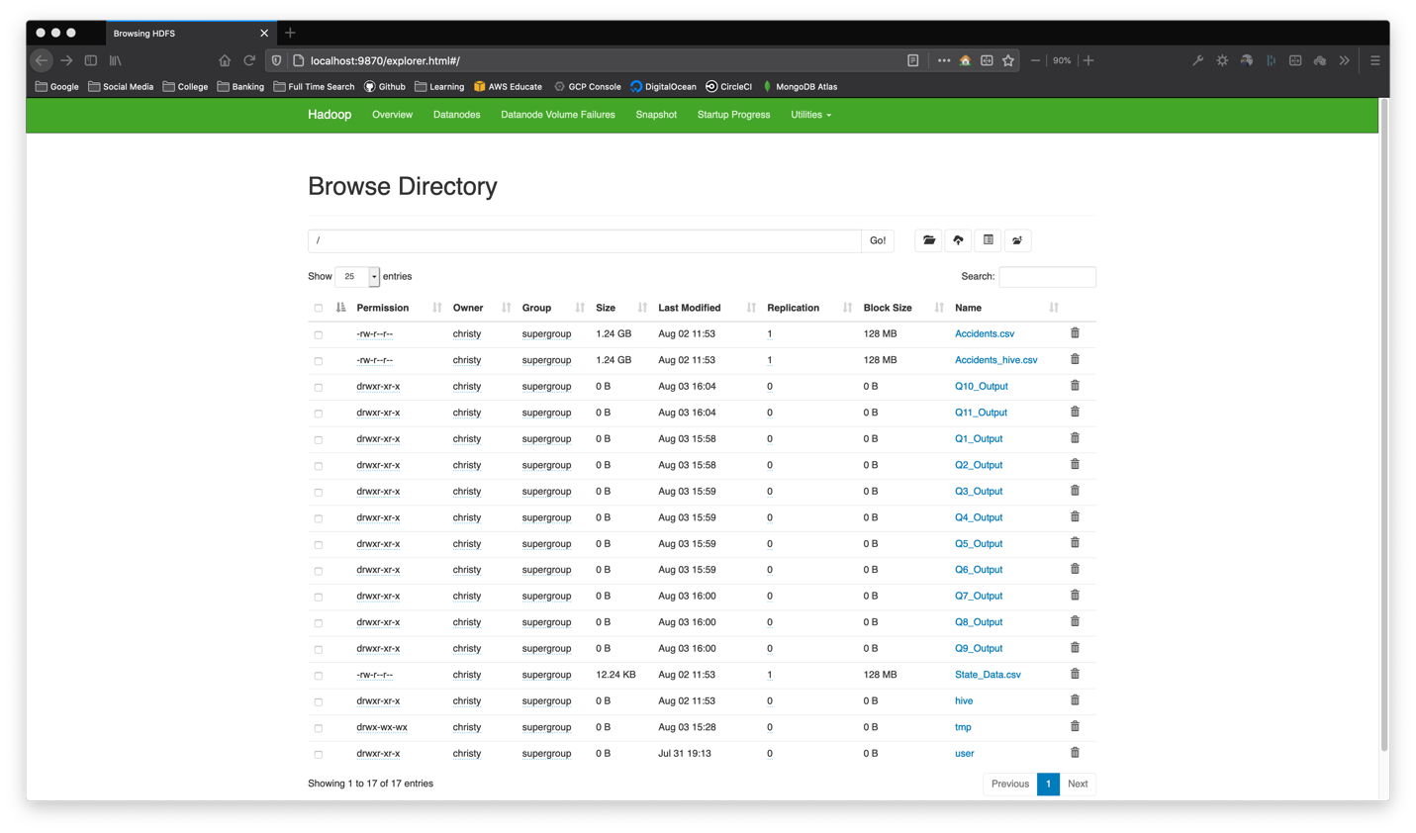

### Number of accidents per month

A Simple MapReduce Program to retrieve the number of accidents per month.

# Number of Accidents Per Month  
hadoop jar ~/Downloads/Projects/BigDataFinalProject/target/BigDataFinalProject-1.0-SNAPSHOT.jar com.hadoop.finalProject.Q1.DriverClass /Accidents.csv /Q1_Output

*Based on the analysis we can conclude that majority of the accidents happen in the months of October (during Fall), June (Summer) and January (Winter) throughout the US.*

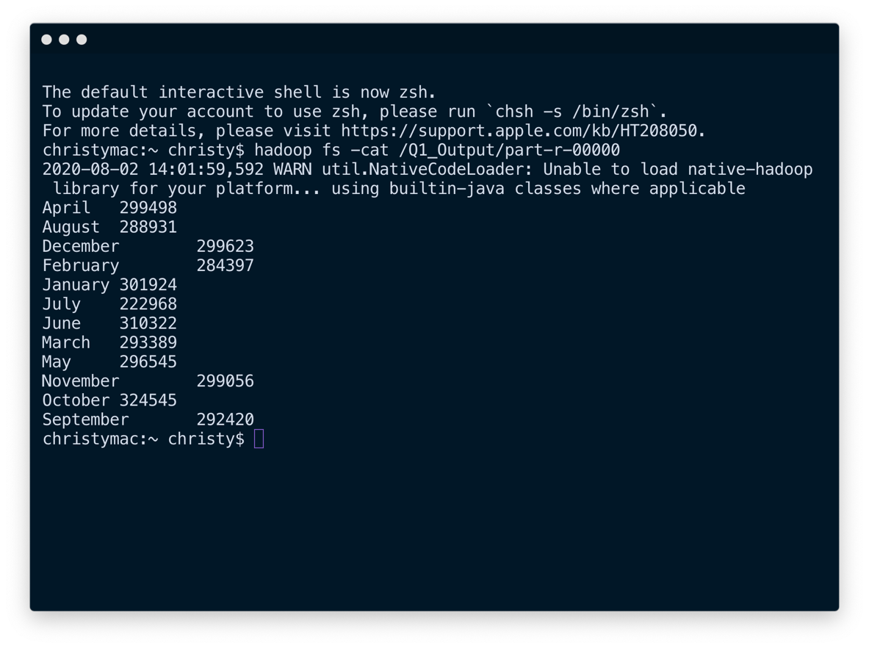

### Number of accidents vs hour of day

This simple MapReduce job performs analysis to determine the number of accidents vs. the hour of day.

# Number of Accidents vs Hour of Day  
hadoop jar ~/Downloads/Projects/BigDataFinalProject/target/BigDataFinalProject-1.0-SNAPSHOT.jar com.hadoop.finalProject.Q2.DriverClass /Accidents.csv /Q2_Output

*Based on the analysis we can conclude that majority of the accidents happen between* ***7: 00 AM to 8:00 AM*** *and in the evening during* ***3:00 PM to 5:00 PM****. These are the times that people travel to and from their workplaces.*

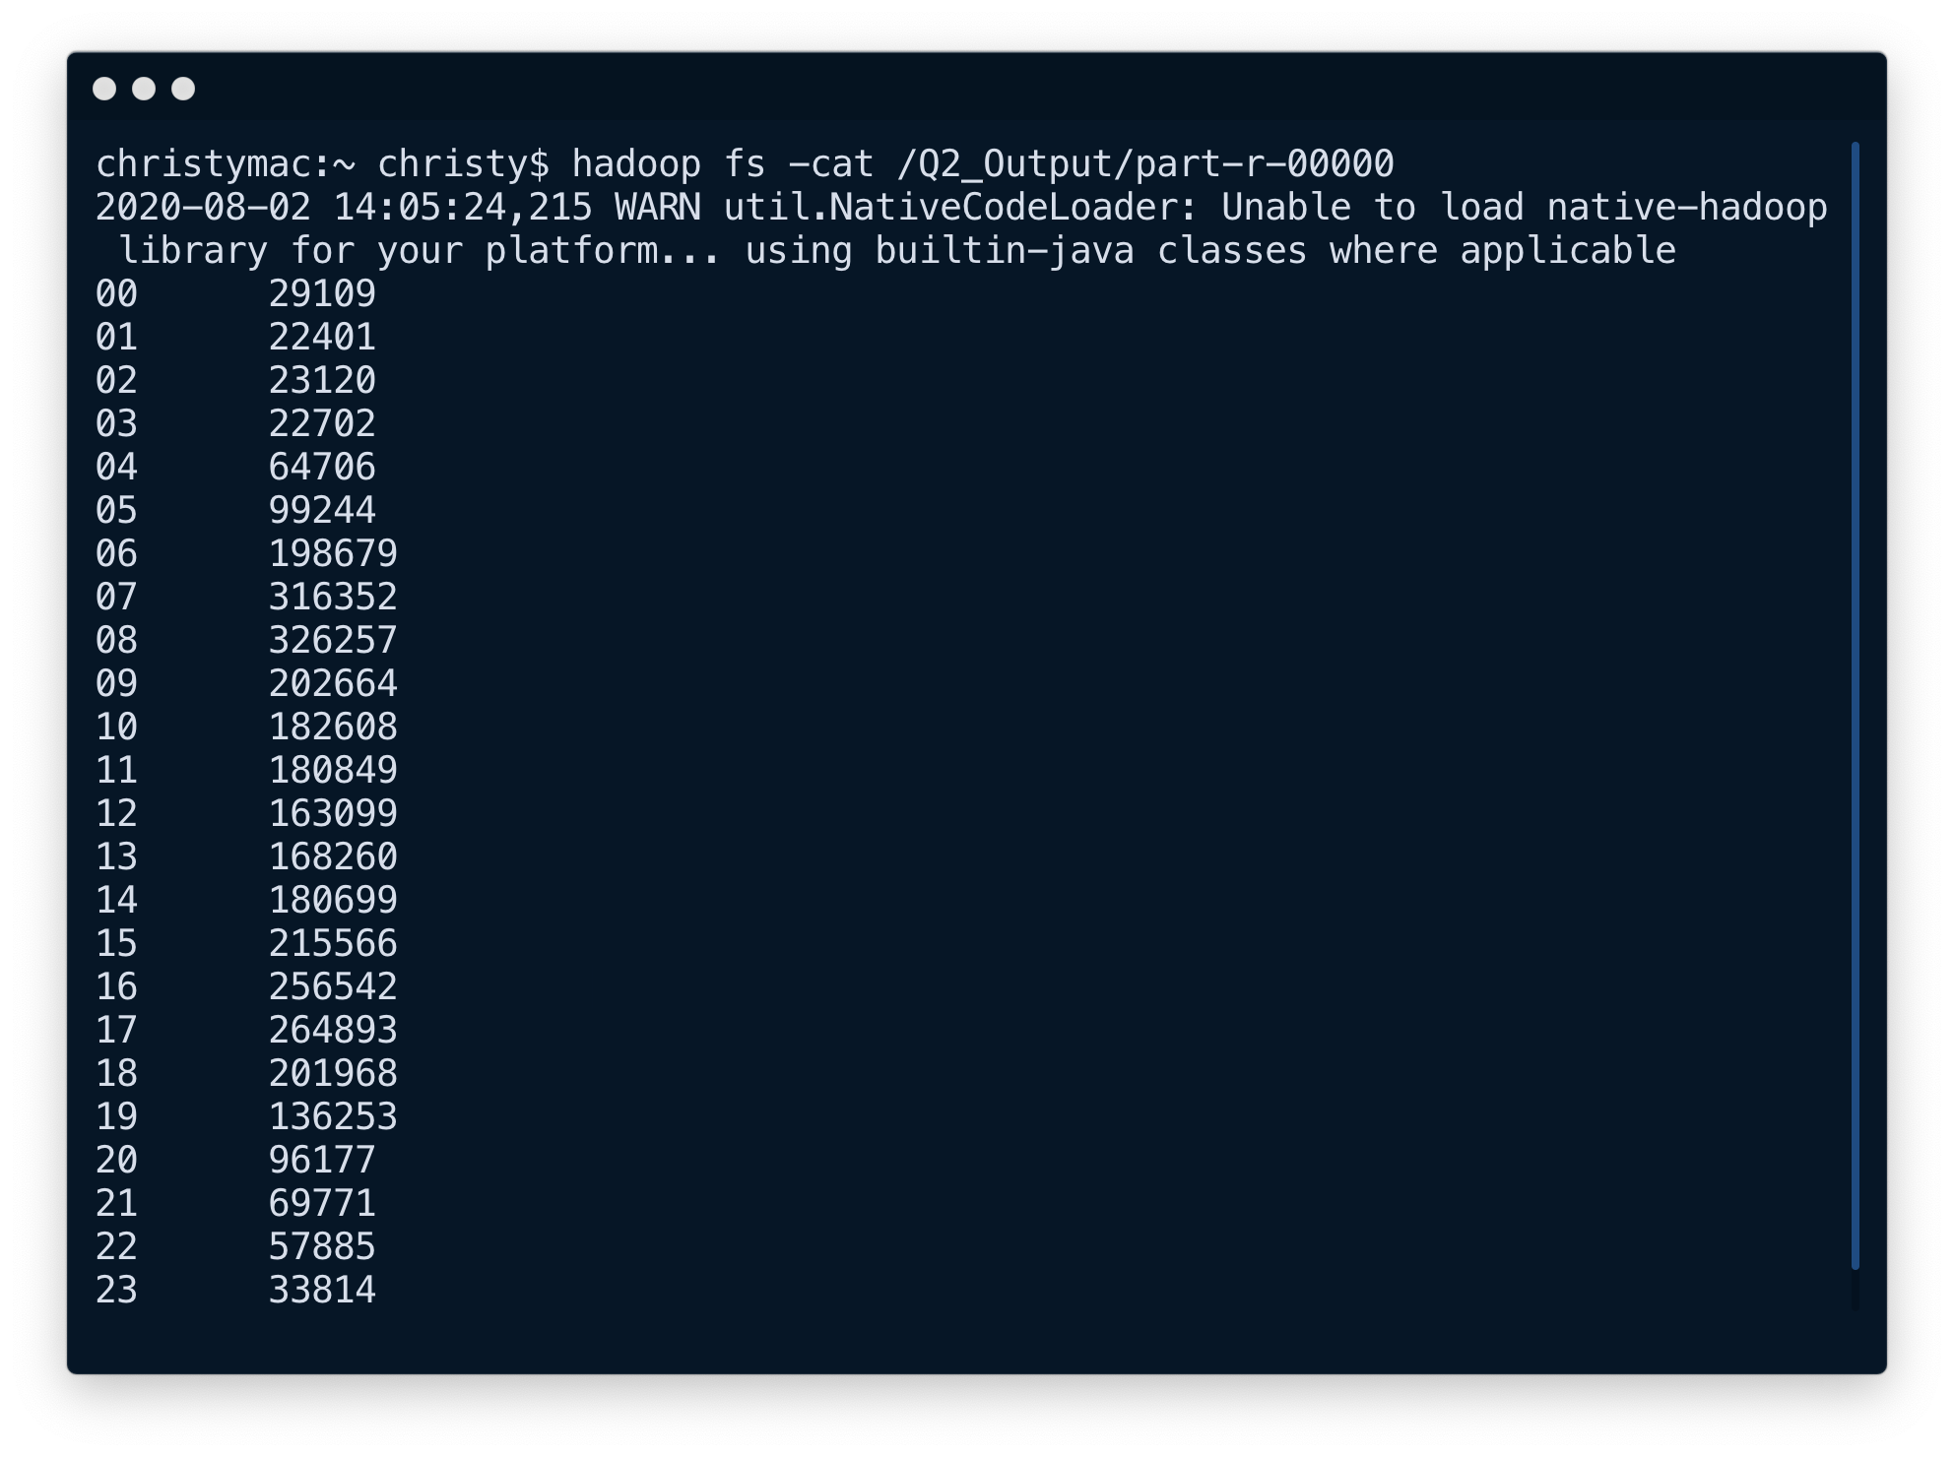

### Number of accidents PER WEEKDAY

This simple MapReduce job performs analysis to determine the number of accidents per weekday

# Number of Accidents Per Weekday  
hadoop jar ~/Downloads/Projects/BigDataFinalProject/target/BigDataFinalProject-1.0-SNAPSHOT.jar com.hadoop.finalProject.Q3.DriverClass /Accidents.csv /Q3_Output

*Based on the analysis we can conclude that majority of the accidents occur during* ***weekdays****. And it seems like people prefer to stay at home during weekends.*

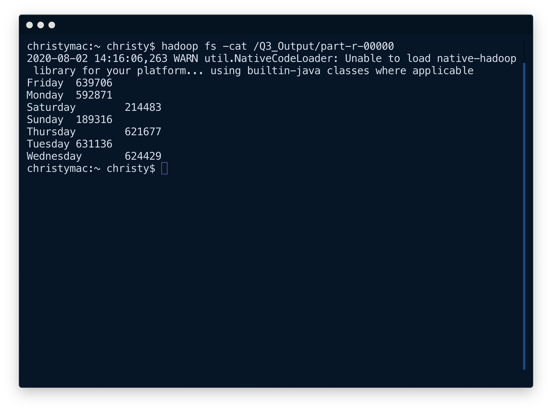

### percentage of accidents per side of the road

This simple MapReduce **Numerical Summarization** job performs analysis to determine the percentage of accidents per side of the road

# Percentage of Accidents per side of the road  
hadoop jar /Users/christy/Downloads/Projects/BigDataFinalProject/target/BigDataFinalProject-1.0-SNAPSHOT.jar com.hadoop.finalProject.Q4.DriverClass /Accidents.csv /Q4_Output

*Based on the analysis we can conclude that vast majority of the accidents happens on the right side of the road.*

*More details can be found here:* [*https://www.picknbuy24.com/column_331.html*](https://www.picknbuy24.com/column_331.html)

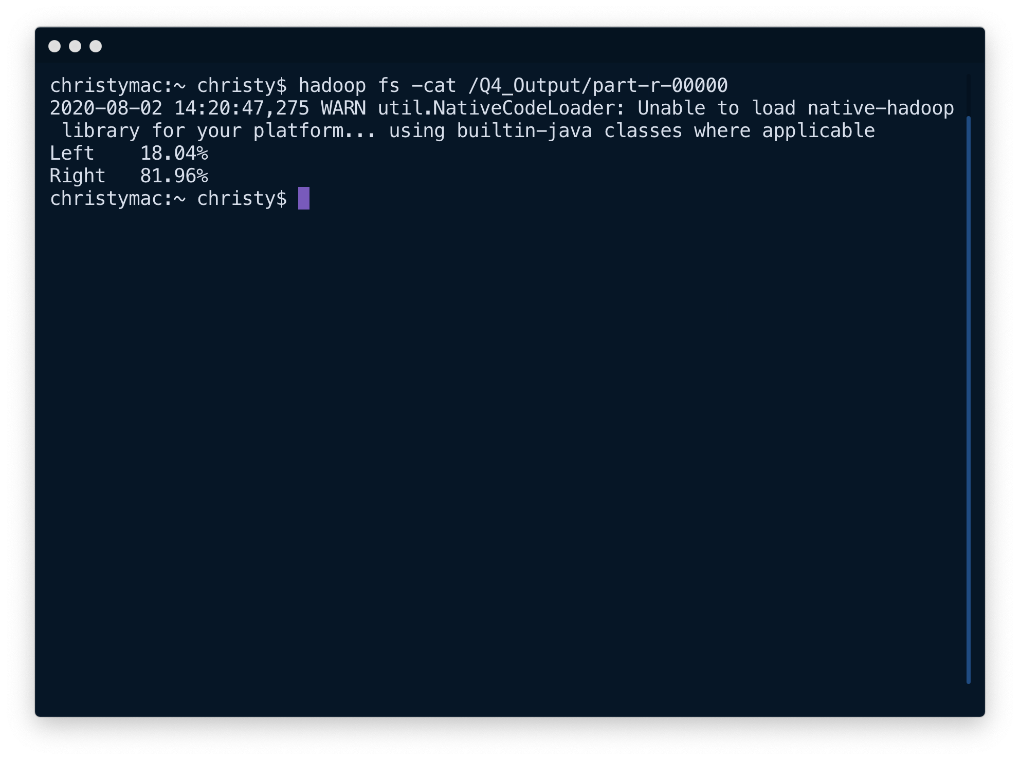

### number of accidents per state

This simple MapReduce job performs analysis to determine the number of accidents per State.

# Accidents Per State  
hadoop jar ~/Downloads/Projects/BigDataFinalProject/target/BigDataFinalProject-1.0-SNAPSHOT.jar com.hadoop.finalProject.Q5.DriverClass /Accidents.csv /Q5_Output

*Further Analysis done in the next part*

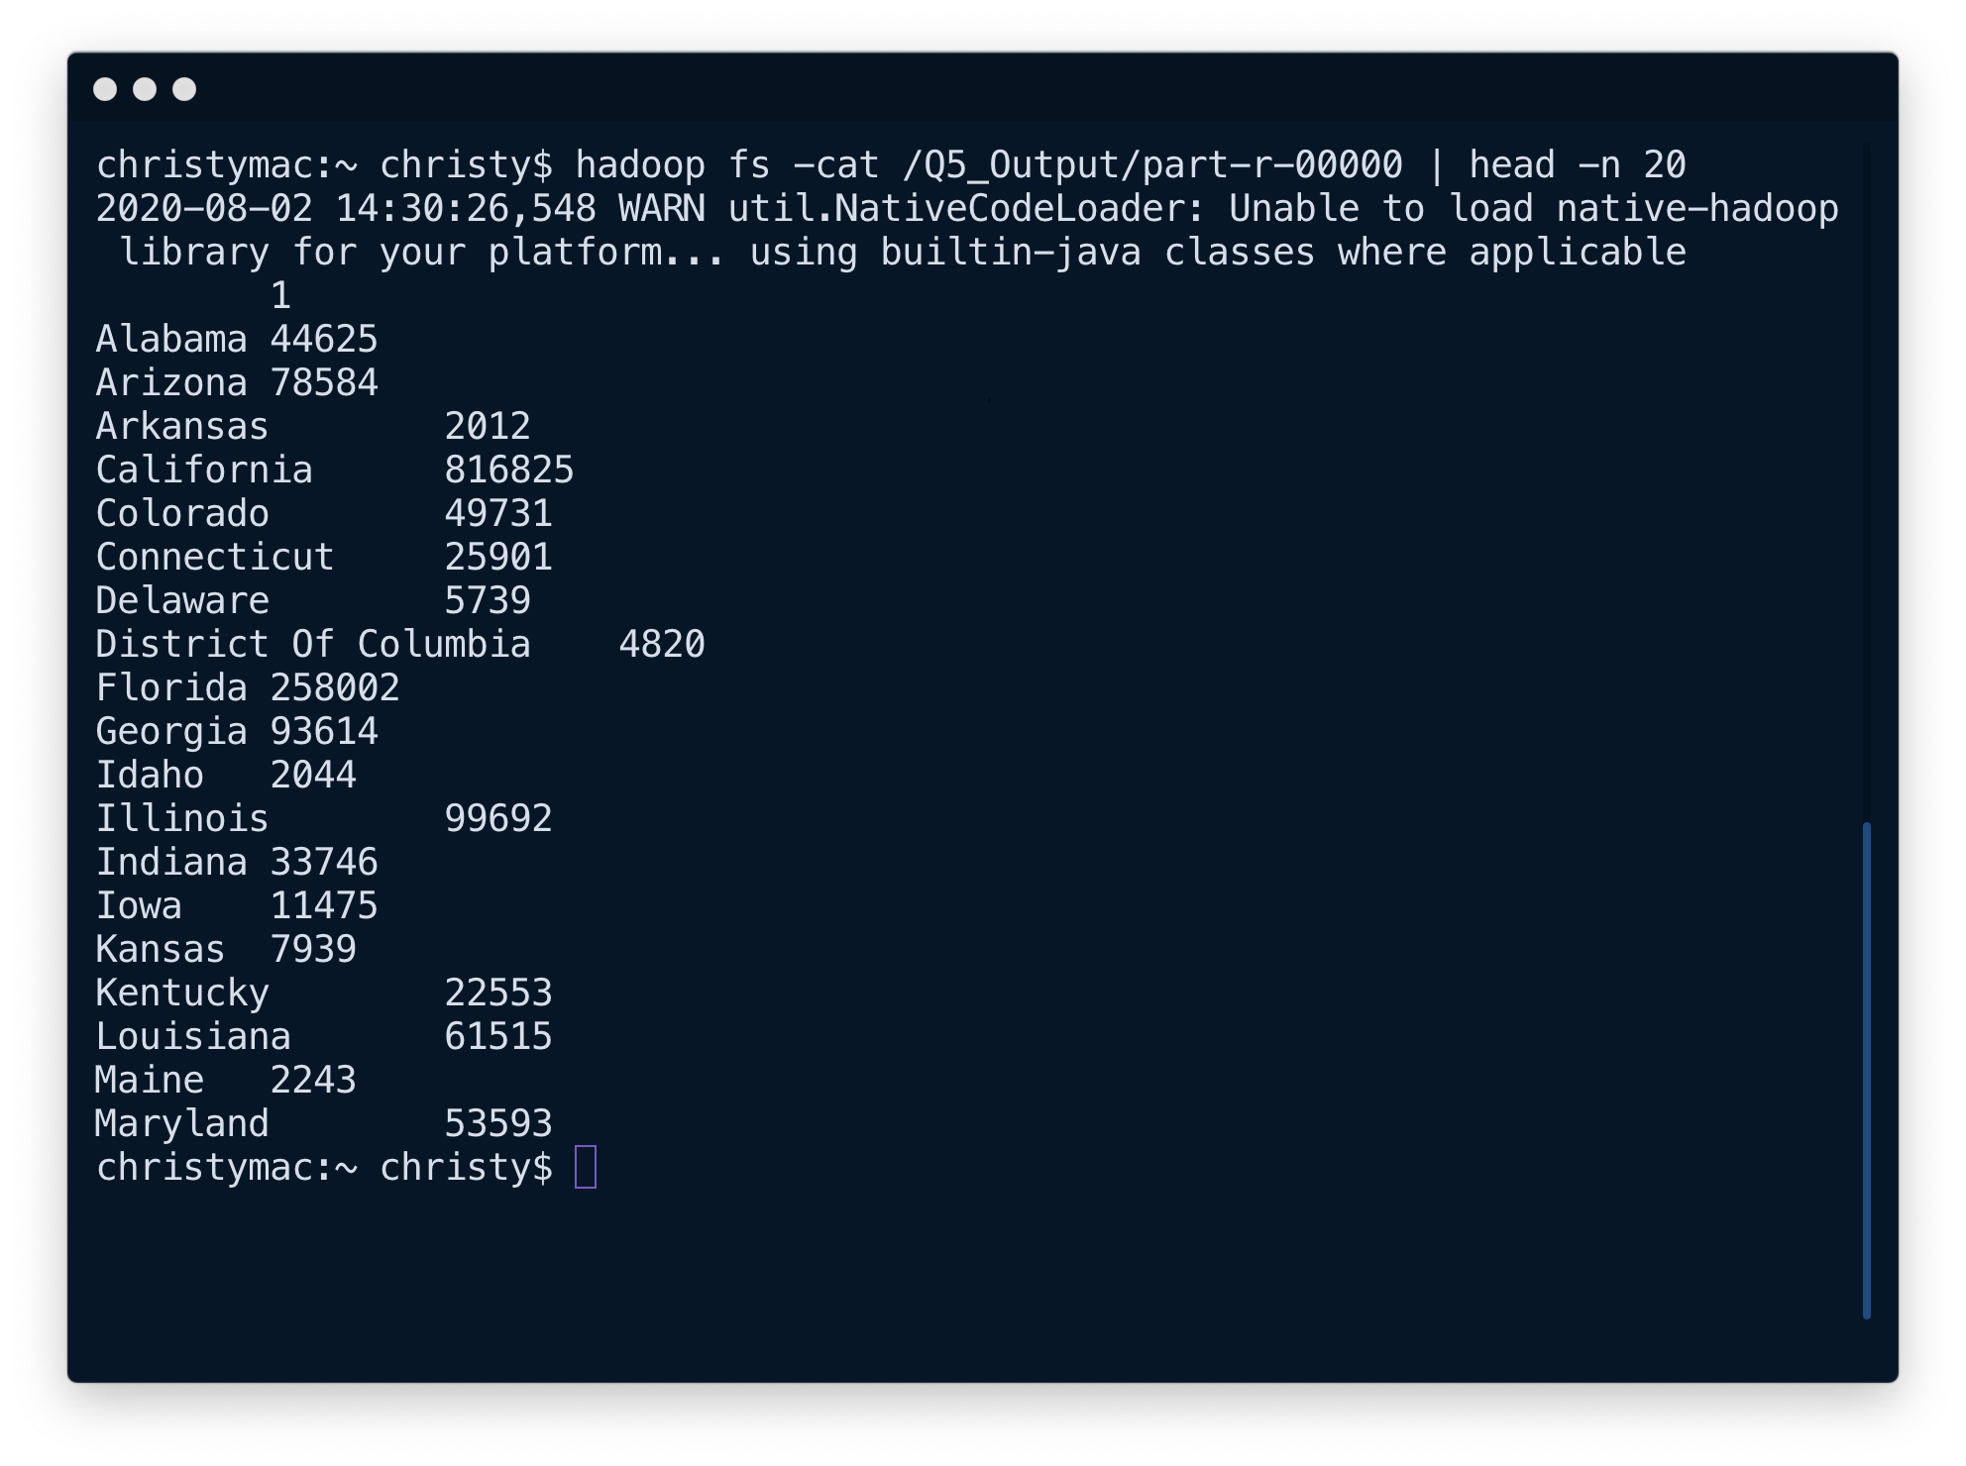

### Top 10 accident prone states

This MapReduce Job uses ***Top n Filtering Pattern*** to filter the states from the previous job to find the states with the top 10 states with the greatest number of accidents.

# Top 10 Accident Prone States  
hadoop jar ~/Downloads/Projects/BigDataFinalProject/target/BigDataFinalProject-1.0-SNAPSHOT.jar com.hadoop.finalProject.Q6.DriverClass /Q5_Output/part-r-00000 /Q6_Output

*Based on the analysis we can conclude that* ***California*** *leads the country in Road Accidents followed by few states in the south.*

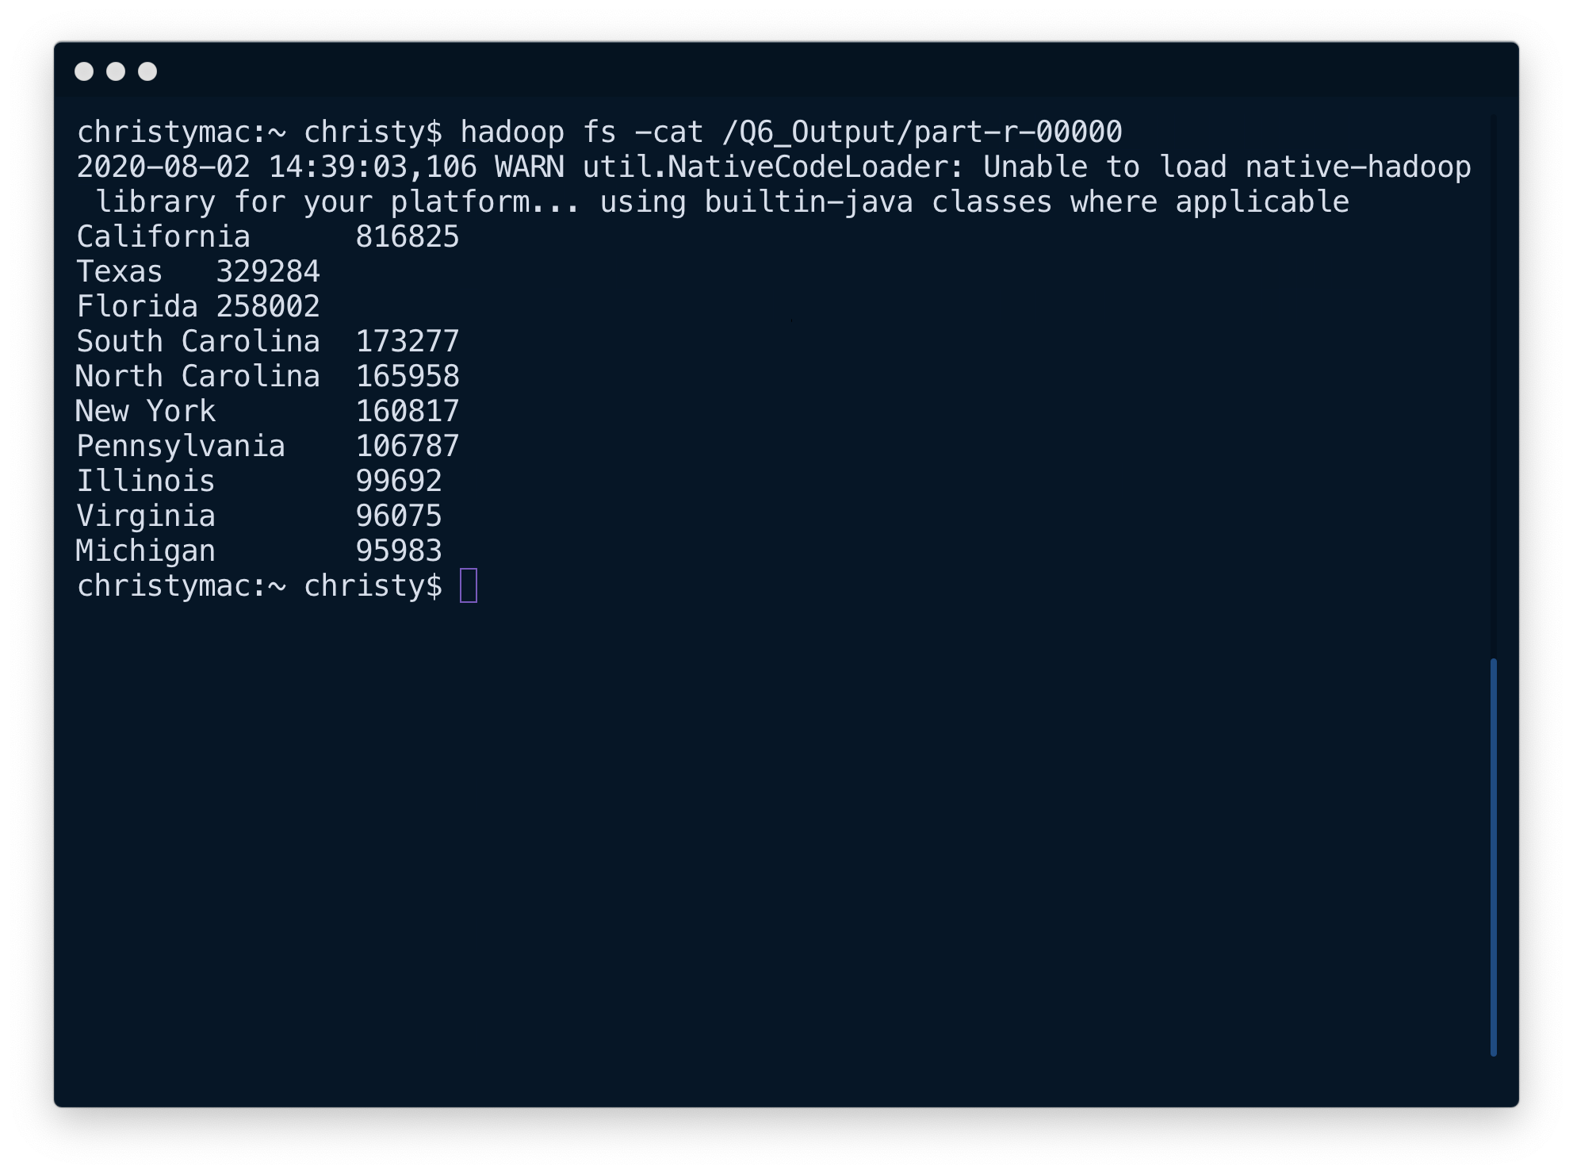

### cities where data was recorded – inverted index

This MapReduce Job uses ***Inverted Index Algorithm*** to find the cities per state (delimited by a ` | `) where the accident data was collected.

# State - Cities = Inverted Index  
hadoop jar ~/Downloads/Projects/BigDataFinalProject/target/BigDataFinalProject-1.0-SNAPSHOT.jar com.hadoop.finalProject.Q7.DriverClass /Accidents.csv /Q7_Output

*Based on the analysis we get all the cities per state where the accident data was collected. This allows us to perform an inverted index search on the data set to get very specific city specific data. (Data below shows the cities in* ***Alabama****)*

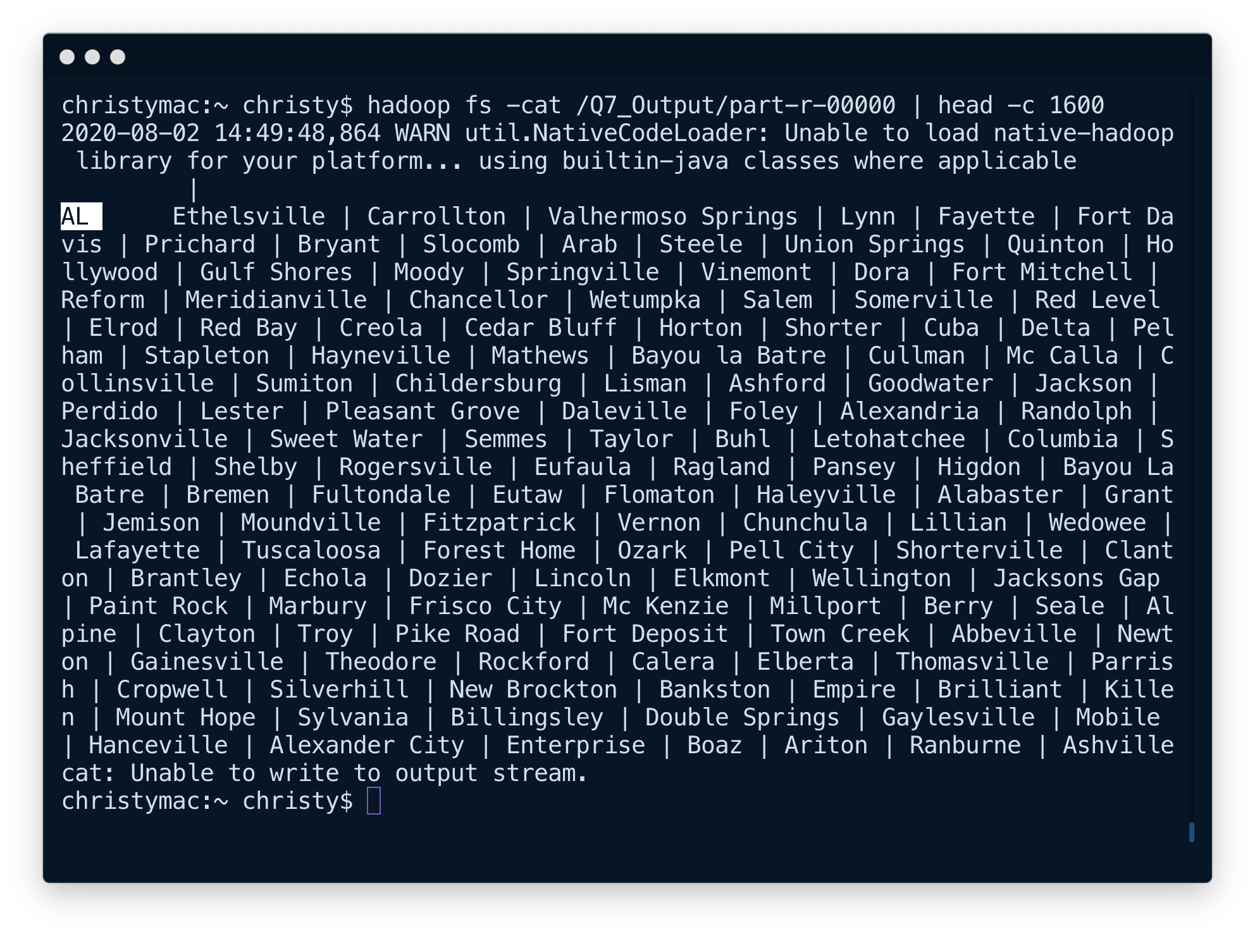

### Average, min and max temperature (f) per serverity

This MapReduce **Numerical Summarization** job performs analysis to determine the minimum, maximum and average temperature (F) per severity of accident. (Severity of an accident ranges from 1 to 4)

# Average, Min and Max Temperature per Severity  
hadoop jar /Users/christy/Downloads/Projects/BigDataFinalProject/target/BigDataFinalProject-1.0-SNAPSHOT.jar com.hadoop.finalProject.Q8.DriverClass /Accidents.csv /Q8_Output

*Based on the analysis we can see that the minimum temperature per severity is quite low (maybe due to snow), but the average temp is normal which means that majority of the accidents happens during clear weather.*

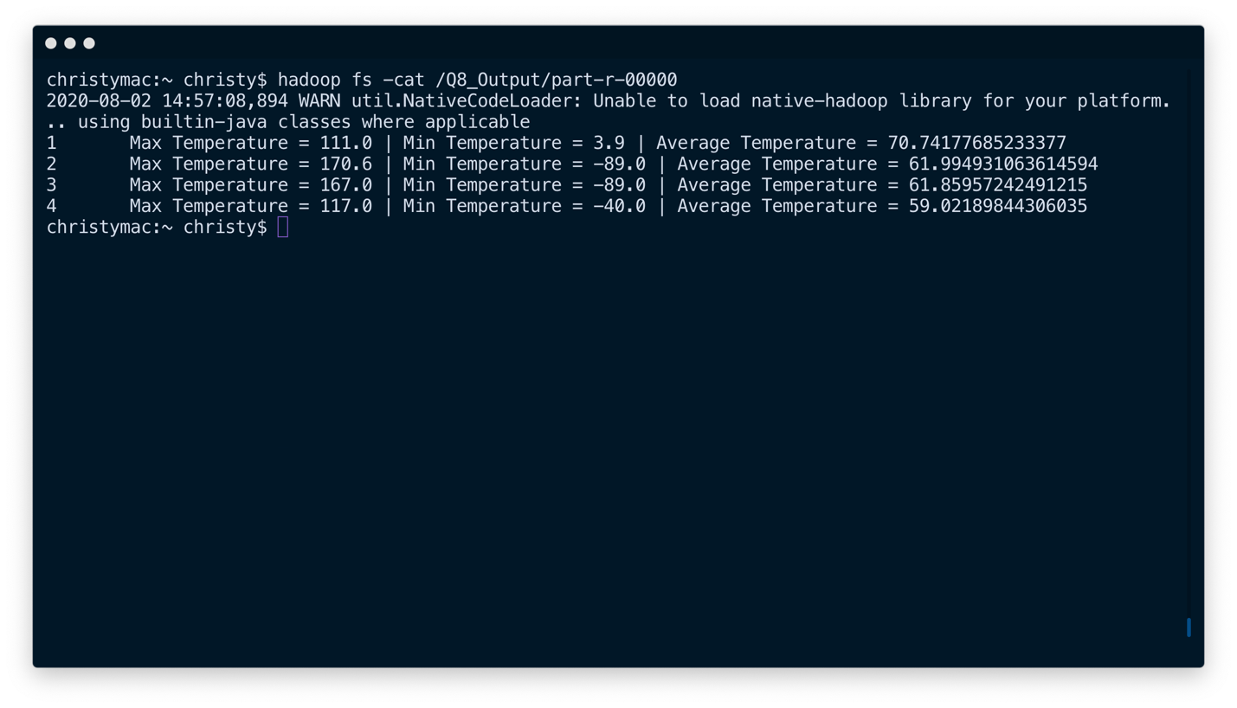

### COUNT OF accidents per state per year – secondary sorted + Partitioned

This MapReduce ***Secondary Sorting*** job uses finds the number of accidents per state per job ***partitioned*** per year. Since the data was collected from 2016 to 2020 (5 years), we have 5 partitions.

# Count of Accidents Per State Per Year (SecondarySorted with 5 Partitions - Per Year)  
hadoop jar ~/Downloads/Projects/BigDataFinalProject/target/BigDataFinalProject-1.0-SNAPSHOT.jar com.hadoop.finalProject.Q9.DriverClass /Accidents.csv /Q9_Output

*PARTITIONS:*

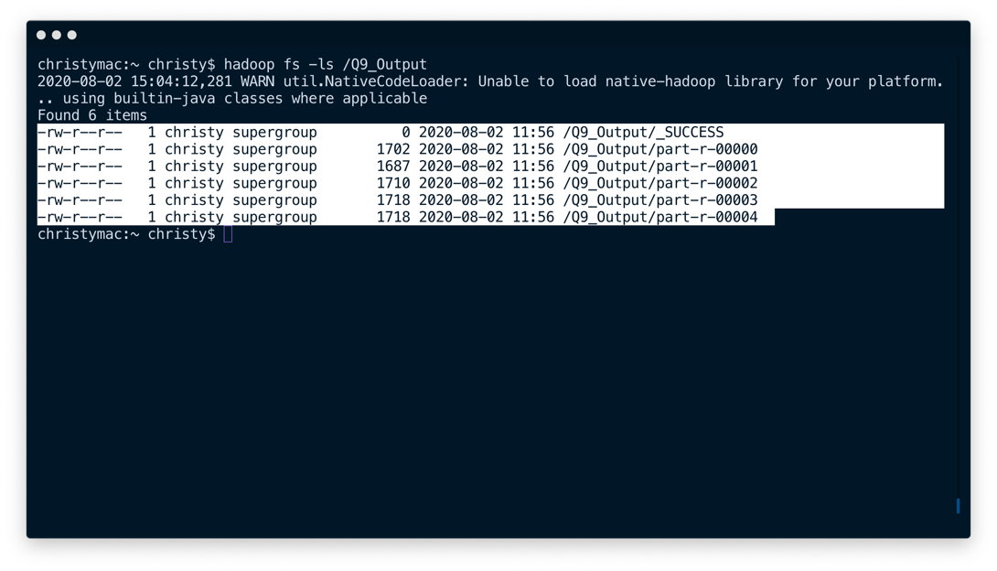

*Below is the data for accidents per state for the year 2020;*

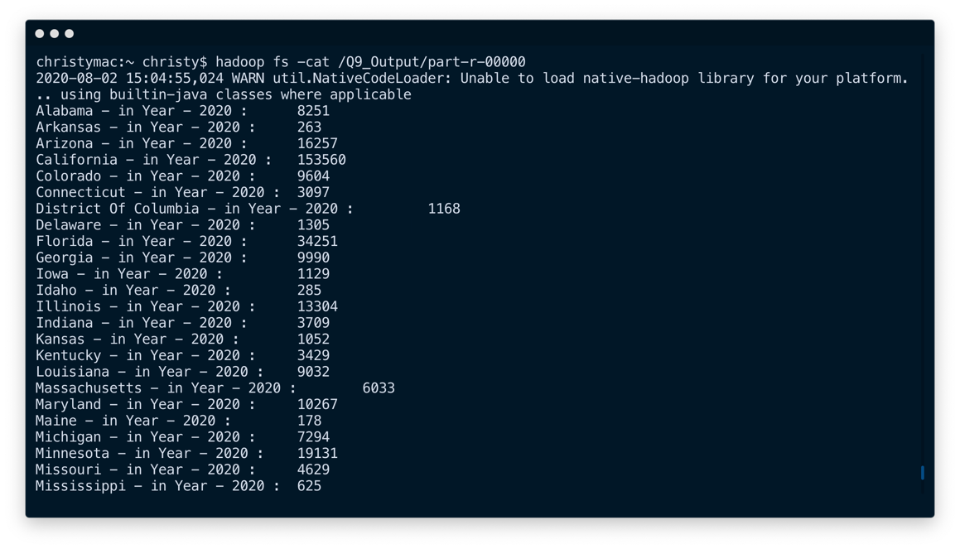

### Partitioning data per state – Inner JOIN

This MapReduce **Partitioning** Job divides the large ~1.3 GB file into smaller files where each file holds data for a particular state. It also replaces the state abbreviation to the full state name using **Inner Join**. *The other .csv file holds abbreviation -> State Name data.*

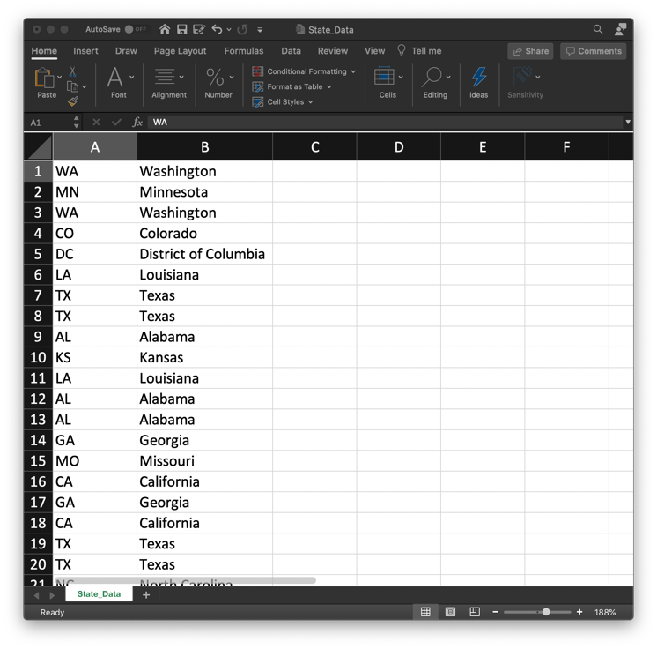

# Divide file into partitions divided by state  
hadoop jar ~Downloads/Projects/BigDataFinalProject/target/BigDataFinalProject-1.0-SNAPSHOT.jar com.hadoop.finalProject.Q10.DriverClass /Accidents.csv /State_Data.csv /Q10_Output

*50 PARTITIONS:*

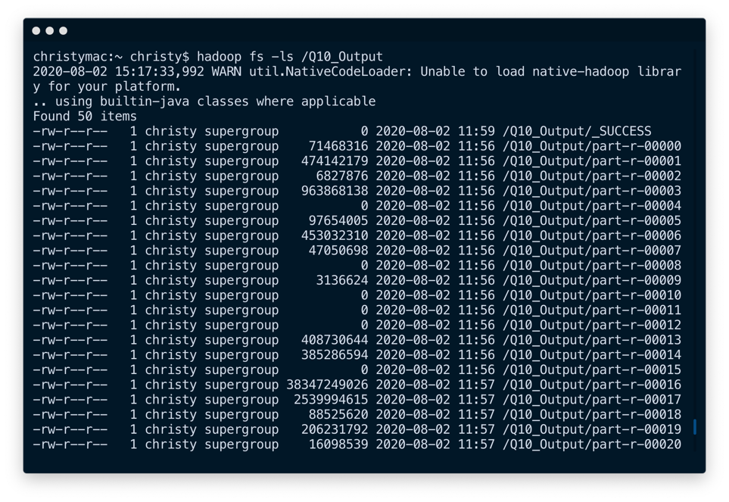

*Below is the file that holds only data for* ***District of Columbia (DC)****;*

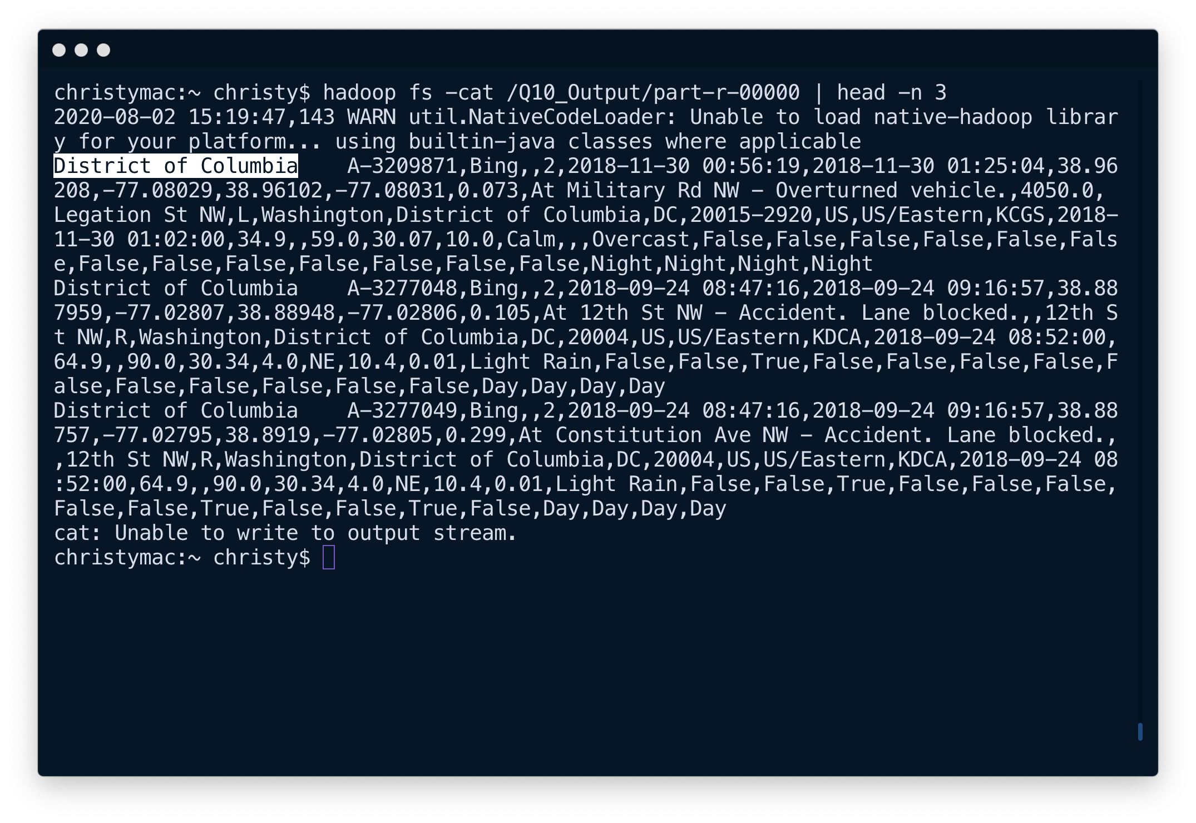

*Below is the file that holds only data for* ***South Carolina****;*

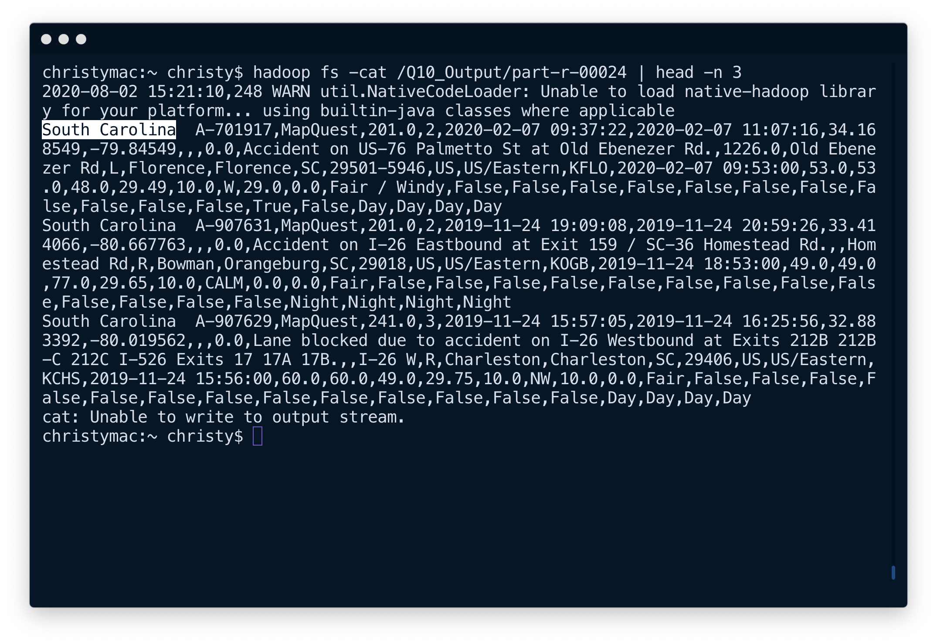

### percentage of accidents vs. PROXIMITY To traffic object

This MapReduce Job finds the percentage of accidents vs. the proximity to traffic object. This **custom algorithm** uses a lot of columns from the data set to produce 2 columns in the end result. It also does simple calculations to find the percentage.

# Proximity to Traffic Object (Percentage / per all traffic)  
hadoop jar ~Downloads/Projects/BigDataFinalProject/target/BigDataFinalProject-1.0-SNAPSHOT.jar com.hadoop.finalProject.Q11.DriverClass /Accidents.csv /Q11_Output

*Based on the analysis we can conclude that majority of the accidents occur near the* ***traffic signal*** *followed by* ***Crossings****.*

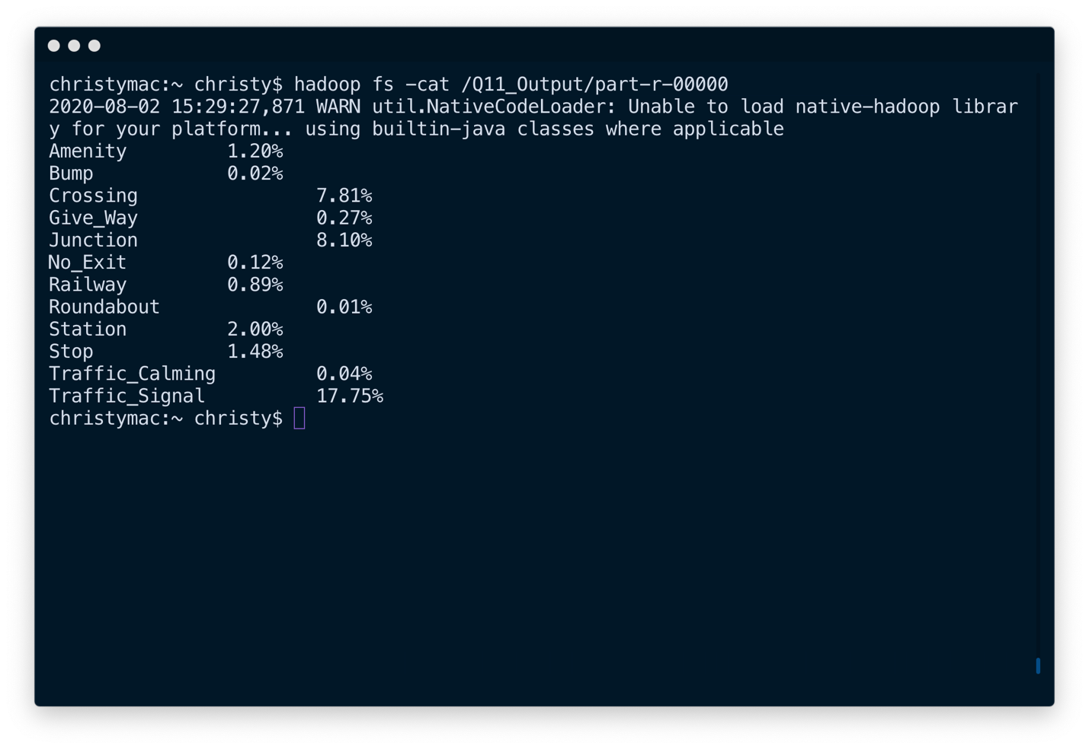

### automation using bash script

Everything from packaging the project to starting the Hadoop Cluster, importing files to HDFS, running MapReduce jobs and Hive/Pig Config were automated using a Bash Shell Script. By running the bash script, the entire MapReduce part of this project was executed in less than 10 minutes and the results were waiting in HDFS.

#!/bin/bash  
  
# Generate JAR file  
mvn package &&  
  
#-----------------------------------------------#  
  
# Start Hadoop  
cd /usr/local/opt/hadoop/sbin &&  
./start-dfs.sh  
  
# Put files into HDFS  
hadoop fs -put ~/Downloads/Accidents.csv / &&  
hadoop fs -put ~/Downloads/State_Data.csv / &&  
  
#-----------------------------------------------#  
  
# Hive config  
hadoop fs -mkdir /hive &&  
hadoop fs -mkdir /hive/warehouse &&  
hadoop fs -put ~/Downloads/Accidents_hive.csv / &&  
  
#-----------------------------------------------#  
  
# Number of Accidents Per Month  
hadoop jar /Users/christy/Downloads/Projects/BigDataFinalProject/target/BigDataFinalProject-1.0-SNAPSHOT.jar com.hadoop.finalProject.Q1.DriverClass /Accidents.csv /Q1_Output &&  
  
# Number of Accidents vs Hour of Day  
hadoop jar /Users/christy/Downloads/Projects/BigDataFinalProject/target/BigDataFinalProject-1.0-SNAPSHOT.jar com.hadoop.finalProject.Q2.DriverClass /Accidents.csv /Q2_Output &&  
  
# Number of Accidents Per Weekday  
hadoop jar /Users/christy/Downloads/Projects/BigDataFinalProject/target/BigDataFinalProject-1.0-SNAPSHOT.jar com.hadoop.finalProject.Q3.DriverClass /Accidents.csv /Q3_Output &&  
  
# Percentage of Accidents per side of the road  
hadoop jar /Users/christy/Downloads/Projects/BigDataFinalProject/target/BigDataFinalProject-1.0-SNAPSHOT.jar com.hadoop.finalProject.Q4.DriverClass /Accidents.csv /Q4_Output &&  
  
# Accidents Per State  
hadoop jar /Users/christy/Downloads/Projects/BigDataFinalProject/target/BigDataFinalProject-1.0-SNAPSHOT.jar com.hadoop.finalProject.Q5.DriverClass /Accidents.csv /Q5_Output &&

# Top 10 Accident Prone States  
hadoop jar /Users/christy/Downloads/Projects/BigDataFinalProject/target/BigDataFinalProject-1.0-SNAPSHOT.jar com.hadoop.finalProject.Q6.DriverClass /Q5_Output/part-r-00000 /Q6_Output &&  
  
# State - Cities = Inverted Index  
hadoop jar /Users/christy/Downloads/Projects/BigDataFinalProject/target/BigDataFinalProject-1.0-SNAPSHOT.jar com.hadoop.finalProject.Q7.DriverClass /Accidents.csv /Q7_Output &&  
  
# Average, Min and Max Temperature per Severity  
hadoop jar /Users/christy/Downloads/Projects/BigDataFinalProject/target/BigDataFinalProject-1.0-SNAPSHOT.jar com.hadoop.finalProject.Q8.DriverClass /Accidents.csv /Q8_Output &&  
  
# Count of Accidents Per State Per Year (SecondarySorted with 5 Partitions - Per Year)  
hadoop jar /Users/christy/Downloads/Projects/BigDataFinalProject/target/BigDataFinalProject-1.0-SNAPSHOT.jar com.hadoop.finalProject.Q9.DriverClass /Accidents.csv /Q9_Output &&  
  
# Divide file into partitions divided by state  
hadoop jar /Users/christy/Downloads/Projects/BigDataFinalProject/target/BigDataFinalProject-1.0-SNAPSHOT.jar com.hadoop.finalProject.Q10.DriverClass /Accidents.csv /State_Data.csv /Q10_Output &&  
  
# Proximity to Traffic Object (Percentage / per all traffic)  
hadoop jar /Users/christy/Downloads/Projects/BigDataFinalProject/target/BigDataFinalProject-1.0-SNAPSHOT.jar com.hadoop.finalProject.Q11.DriverClass /Accidents.csv /Q11_Output

### Mapreduce on aws elastic map reduce (emr)

The MapReduce jobs can also be executed on an AWS EMR Cluster provided the Host machine has AWS CLI tool installed with the AWS credentials configured.

The below Bash script automatically executes the steps in the following order:

1. Package the project using maven to the latest changes made by the developer.
2. Uploads the jar file generated from the previous step to an S3 bucket (Make sure to variable values with respect to your project). The cluster will automatically be destroyed after all the MapReduce jobs are completed successfully.
3. Adds steps to run the MapReduce Jobs.

*After the MapReduce jobs are finished, you can SSH into the Master NameNode from the EC2 instances to check the output from the jobs.*

#!/bin/bash  
  
# Package project to jar file  
mvn package  
  
# Variables (TODO: Change)  
keyName="Lab2"  
projectName="ebds-cluster"  
bucketName="ebds-final-project"  
  
# Upload jar file to S3 bucket  
aws s3 cp ~/Downloads/Projects/BigDataFinalProject/target/BigDataFinalProject-1.0-SNAPSHOT.jar s3://$bucketName/ebds-runnable.jar  
  
# Create a new Cluster  
clusterId=$(aws emr create-cluster \  
 --name $projectName \  
 --use-default-roles \  
 --release-label emr-5.30.1 \  
 --instance-count 3 \  
 --instance-type m5.xlarge \  
 --applications Name=Pig Name=Hive Name=Hadoop \  
 --ec2-attributes KeyName=$keyName \  
 --log-uri s3://$bucketName/logs \  
 --auto-terminate | awk '{print $2}')  
  
# Add Steps to cluster  
aws emr add-steps \  
 --cluster-id $clusterId \  
 --steps Type=CUSTOM_JAR,Name=Q1_Step,ActionOnFailure=CONTINUE,Jar=s3://$bucketName/ebds-runnable.jar,Args=com.hadoop.finalProject.Q1.DriverClass,s3://$bucketName/Accidents.csv,/Q1_Output \  
 Type=CUSTOM_JAR,Name=Q2_Step,ActionOnFailure=CONTINUE,Jar=s3://$bucketName/ebds-runnable.jar,Args=com.hadoop.finalProject.Q2.DriverClass,s3://$bucketName/Accidents.csv,/Q2_Output \  
 Type=CUSTOM_JAR,Name=Q3_Step,ActionOnFailure=CONTINUE,Jar=s3://$bucketName/ebds-runnable.jar,Args=com.hadoop.finalProject.Q3.DriverClass,s3://$bucketName/Accidents.csv,/Q3_Output \  
 Type=CUSTOM_JAR,Name=Q4_Step,ActionOnFailure=CONTINUE,Jar=s3://$bucketName/ebds-runnable.jar,Args=com.hadoop.finalProject.Q4.DriverClass,s3://$bucketName/Accidents.csv,/Q4_Output \  
 Type=CUSTOM_JAR,Name=Q5_Step,ActionOnFailure=CONTINUE,Jar=s3://$bucketName/ebds-runnable.jar,Args=com.hadoop.finalProject.Q5.DriverClass,s3://$bucketName/Accidents.csv,/Q5_Output \  
 Type=CUSTOM_JAR,Name=Q6_Step,ActionOnFailure=CONTINUE,Jar=s3://$bucketName/ebds-runnable.jar,Args=com.hadoop.finalProject.Q6.DriverClass,s3://$bucketName/Accidents.csv,/Q5_Output/part-r-00000,/Q6_Output \  
 Type=CUSTOM_JAR,Name=Q7_Step,ActionOnFailure=CONTINUE,Jar=s3://$bucketName/ebds-runnable.jar,Args=com.hadoop.finalProject.Q7.DriverClass,s3://$bucketName/Accidents.csv,/Q7_Output \  
 Type=CUSTOM_JAR,Name=Q8_Step,ActionOnFailure=CONTINUE,Jar=s3://$bucketName/ebds-runnable.jar,Args=com.hadoop.finalProject.Q8.DriverClass,s3://$bucketName/Accidents.csv,/Q8_Output \  
 Type=CUSTOM_JAR,Name=Q9_Step,ActionOnFailure=CONTINUE,Jar=s3://$bucketName/ebds-runnable.jar,Args=com.hadoop.finalProject.Q9.DriverClass,s3://$bucketName/Accidents.csv,/Q9_Output \  
 Type=CUSTOM_JAR,Name=Q10_Step,ActionOnFailure=CONTINUE,Jar=s3://$bucketName/ebds-runnable.jar,Args=com.hadoop.finalProject.Q10.DriverClass,s3://$bucketName/Accidents.csv,s3://$bucketName/State_Data.csv,/Q10_Output \  
 Type=CUSTOM_JAR,Name=Q11_Step,ActionOnFailure=CONTINUE,Jar=s3://$bucketName/ebds-runnable.jar,Args=com.hadoop.finalProject.Q11.DriverClass,s3://$bucketName/Accidents.csv,/Q11_Output

S3 bucket with files uploaded:

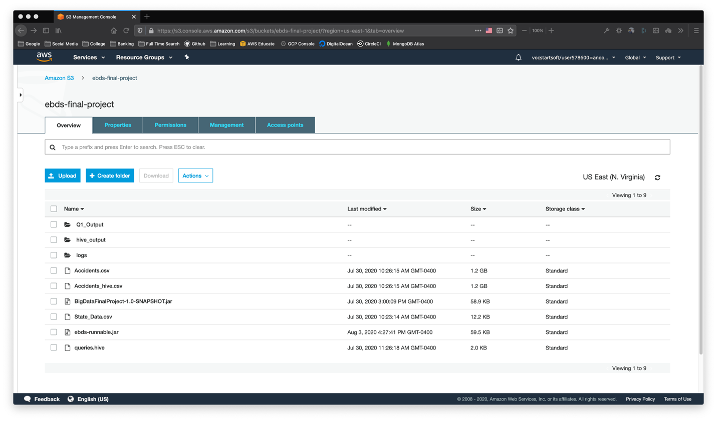

AWS Provisioning an EMR Cluster:

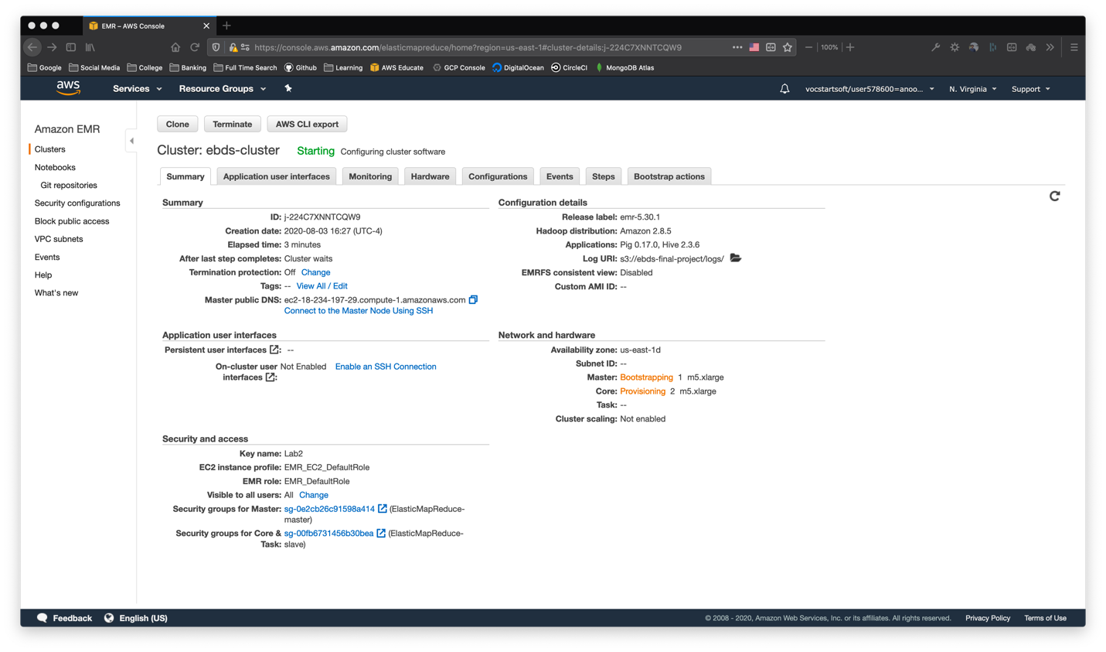

EMR MapReduce Jobs Queued:

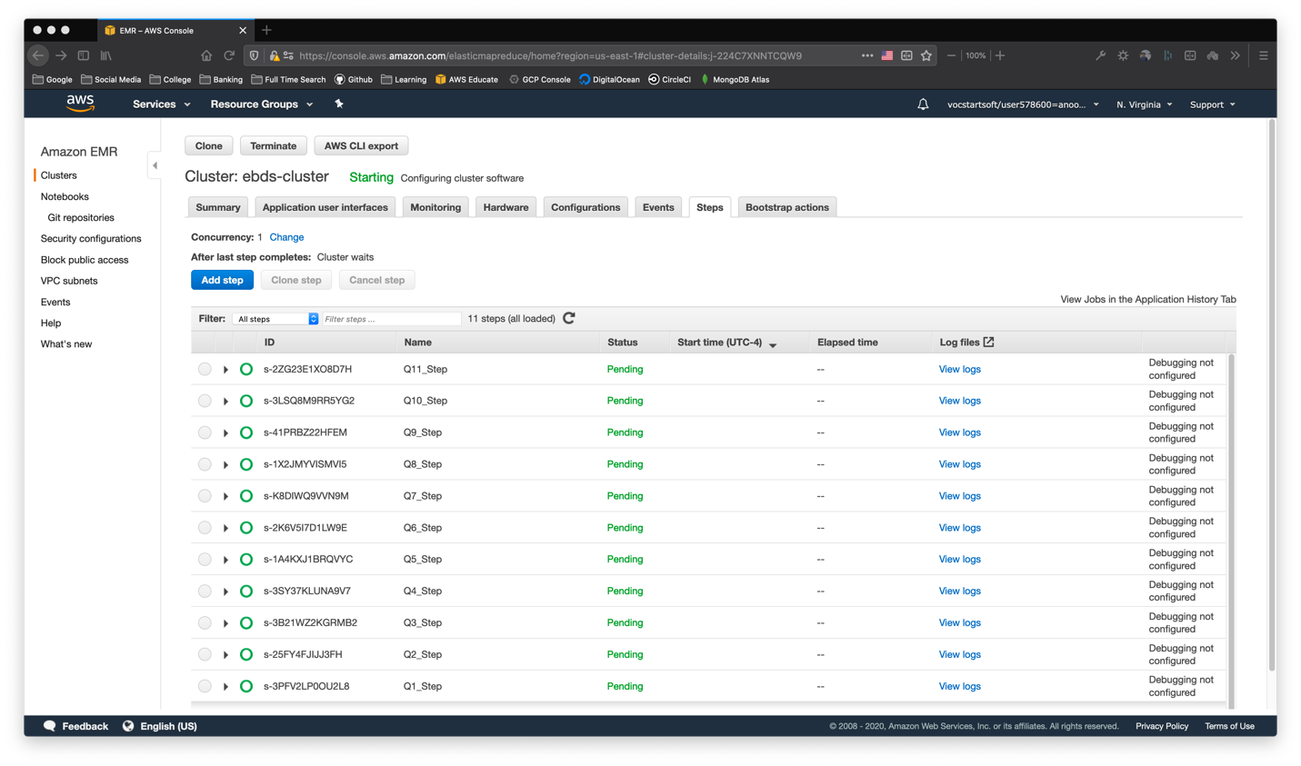

After MapReduce Jobs are executed and SSH into Master Machine:

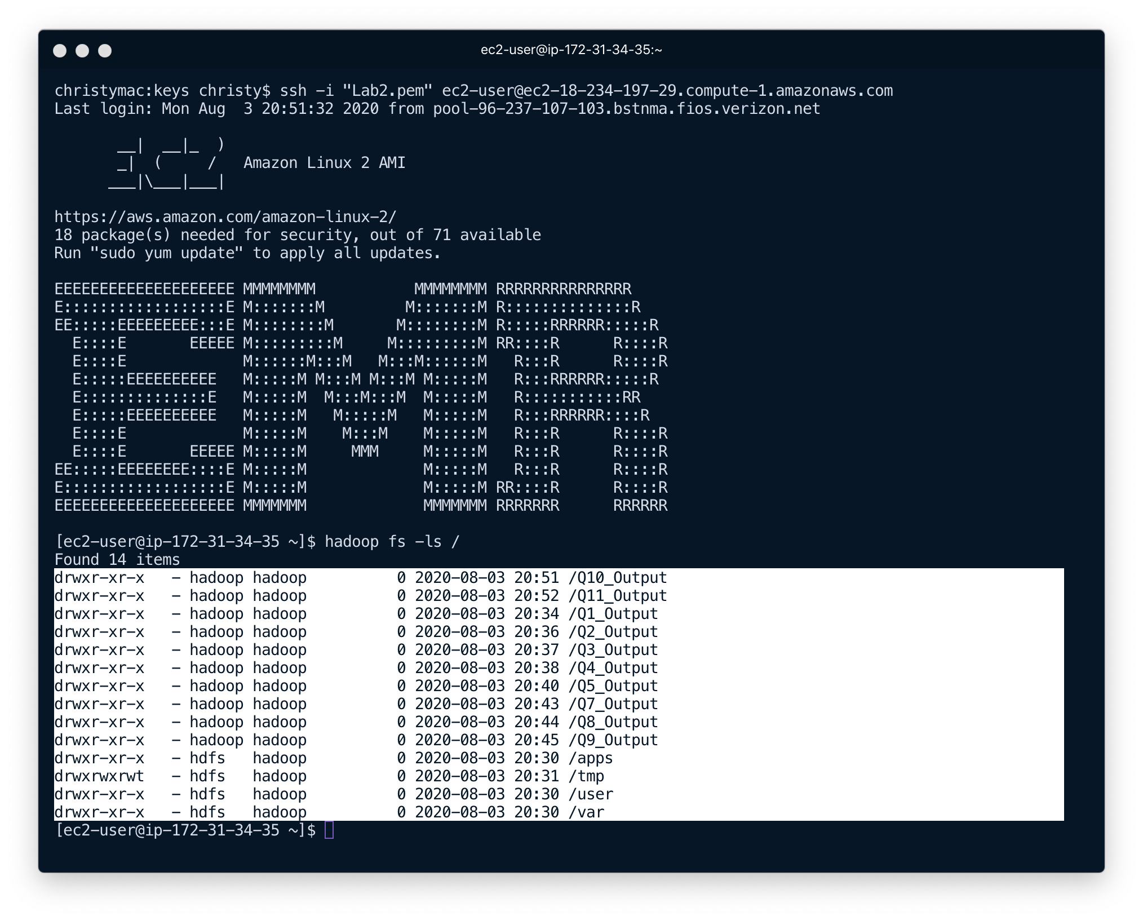

### Data analysis using apache pig

**Apache Pig** is a platform for analyzing large data sets that consists of a high-level language for expressing data analysis programs, coupled with infrastructure for evaluating these programs. The salient property of Pig programs is that their structure is amenable to substantial parallelization, which in turns enables them to handle very large data sets.

At the present time, Pig's infrastructure layer consists of a compiler that produces sequences of Map-Reduce programs, for which large-scale parallel implementations already exist (e.g., the Hadoop subproject). Pig's language layer currently consists of a textual language called Pig Latin, which has the following key properties:

* **Ease of programming.** It is trivial to achieve parallel execution of simple, "embarrassingly parallel" data analysis tasks. Complex tasks comprised of multiple interrelated data transformations are explicitly encoded as data flow sequences, making them easy to write, understand, and maintain.
* **Optimization opportunities.** The way in which tasks are encoded permits the system to optimize their execution automatically, allowing the user to focus on semantics rather than efficiency.
* **Extensibility.** Users can create their own functions to do special-purpose processing.

### Top 10 Weather Conditions during Accidents in Massachusetts (MA)

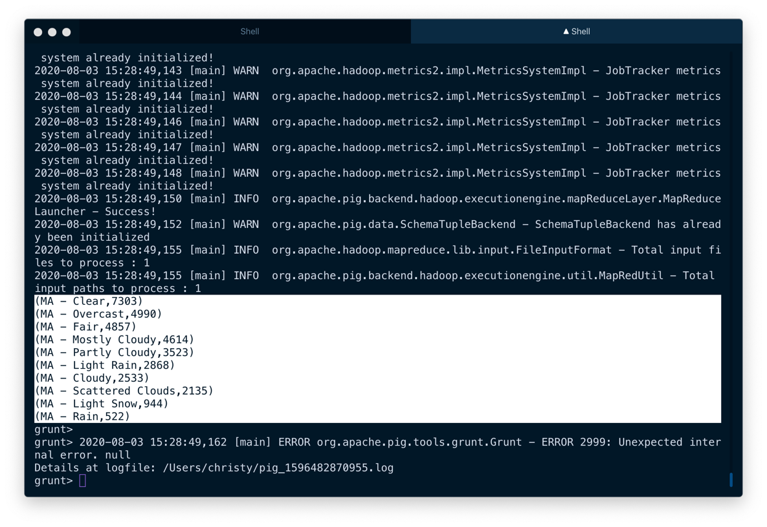grunt> run ~/Downloads/Projects/BigDataFinalProject/pig/q1.pig

Pig Script:

DEFINE CSVLoader org.apache.pig.piggybank.storage.CSVLoader();  
  
data = LOAD '/Accidents.csv' USING CSVLoader() AS (ID:CHARARRAY, Source:CHARARRAY, TMC:DOUBLE, Severity:INT, Start_Time:CHARARRAY, End_Time:CHARARRAY, Start_Lat:DOUBLE, Start_Lng:DOUBLE, End_Lat:DOUBLE, End_Lng:DOUBLE, Distance:DOUBLE, Description:CHARARRAY, Number:DOUBLE, Street:CHARARRAY, Side:CHARARRAY, City:CHARARRAY, County:CHARARRAY, State:CHARARRAY, Zipcode:CHARARRAY, Country:CHARARRAY, Timezone:CHARARRAY, Airport_Code:CHARARRAY, Weather_Timestamp:CHARARRAY, Temperature:DOUBLE, Wind_Chill:DOUBLE, Humidity:DOUBLE, Pressure:DOUBLE, Visibility:DOUBLE, Wind_Direction:CHARARRAY, Wind_Speed:DOUBLE, Precipitation:DOUBLE, Weather_Condition:CHARARRAY, Amenity:BOOLEAN, Bump:BOOLEAN, Crossing:BOOLEAN, Give_Way:BOOLEAN, Junction:BOOLEAN, No_Exit:BOOLEAN, Railway:BOOLEAN, Roundabout:BOOLEAN, Station:BOOLEAN, Stop:BOOLEAN, Traffic_Calming:BOOLEAN, Traffic_Signal:BOOLEAN, Turning_Loop:BOOLEAN, Sunrise_Sunset:CHARARRAY, Civil_Twilight:CHARARRAY, Nautical_Twilight:CHARARRAY, Astronomical_Twilight:CHARARRAY);  
  
inter = FOREACH data GENERATE State, Weather_Condition ;  
  
ma = FILTER inter BY State == 'MA' AND NOT Weather_Condition == '';  
  
grouped = GROUP ma BY CONCAT (State, ' - ', Weather_Condition);  
  
concat_count = FOREACH grouped GENERATE group, COUNT(ma) AS cnt;  
  
sorted = ORDER concat_count BY cnt DESC;  
  
top = LIMIT sorted 10;  
  
DUMP top;

### Cities in Massachusetts where accidents happen during snowy days

grunt> run ~/Downloads/Projects/BigDataFinalProject/pig/q2.pig

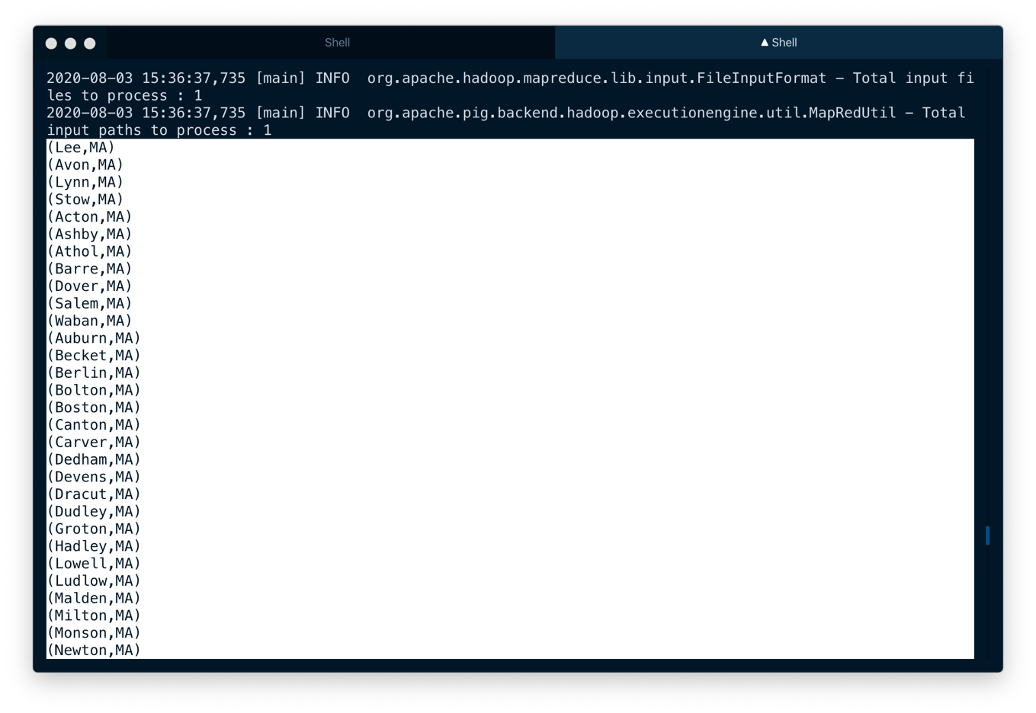

Pig Script: (Uses Inner Join)

-- Cities in Massachusetts where accidents happen during snowy days  
  
-- Find rows in State = MA where it snowed during accidents

weather_data = FOREACH data GENERATE ID, State, Weather_Condition;  
  
ma = FILTER weather_data BY State == 'MA' AND NOT Weather_Condition == '';  
  
snowy = FILTER ma BY Weather_Condition == 'Light Snow' OR Weather_Condition == 'Snow';  
  
-----------------------------------------------------------------  
  
-- Find All cities in US cities = FOREACH data GENERATE ID, City ;  
  
-----------------------------------------------------------------  
  
joined = JOIN cities BY ID, snowy BY ID;  
  
intermediate = FOREACH joined GENERATE City, State;  
  
result = DISTINCT intermediate;  
  
DUMP result;

### DATA analysis using apache hive

The Apache Hive ™ data warehouse software facilitates reading, writing, and managing large datasets residing in distributed storage using SQL. Structure can be projected onto data already in storage. A command line tool and JDBC driver are provided to connect users to Hive.

$ hive -f ~/Downloads/Projects/BigDataFinalProject/hive/queries.hql

### Number of Accidents per Severity per State (Partitioning)

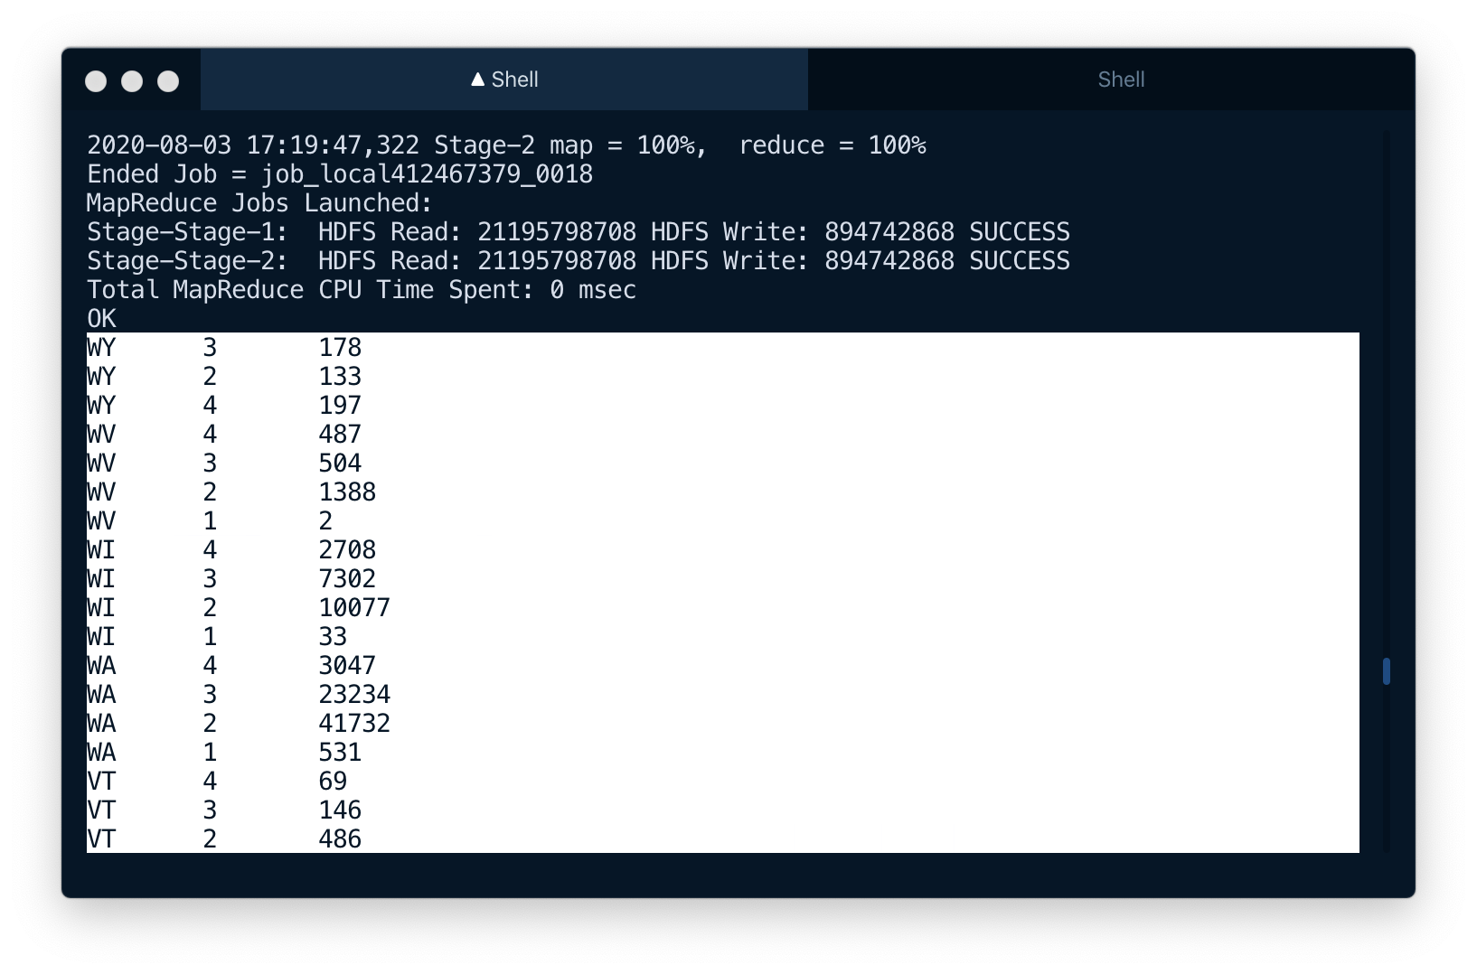

### Number of accidents per timezone

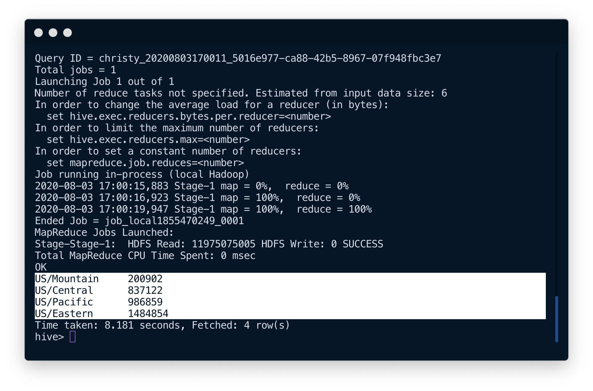

### Top 10 - Weather Condition vs Number of Accident

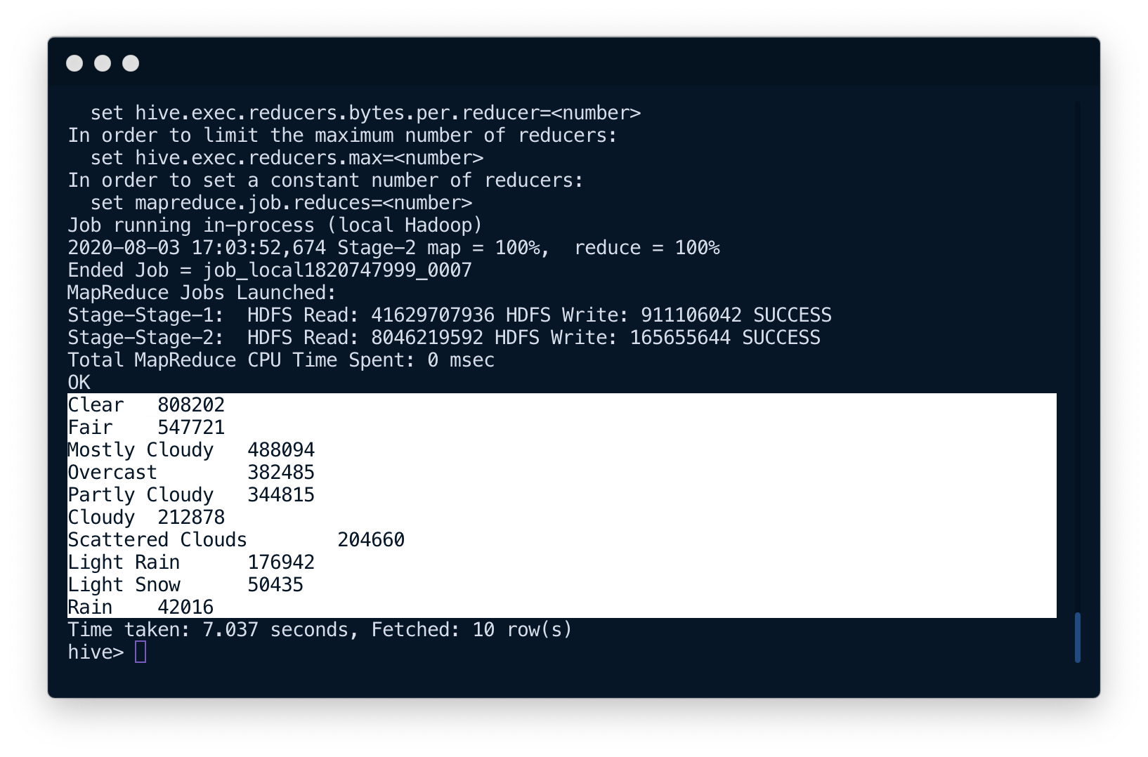

-- Create Table

CREATE TABLE accidents(ID STRING, Source STRING, TMC DOUBLE, Severity INT, Start_Time STRING, End_Time STRING, Start_Lat DOUBLE, Start_Lng DOUBLE, End_Lat DOUBLE, End_Lng DOUBLE, Distance DOUBLE, Description STRING, Number DOUBLE, Street STRING, Side STRING, City STRING, County STRING, State STRING, Zipcode STRING, Country STRING, Timezone STRING, Airport_Code STRING, Weather_Timestamp STRING, Temperature DOUBLE, Wind_Chill DOUBLE,Humidity DOUBLE, Pressure DOUBLE, Visibility DOUBLE, Wind_Direction STRING, Wind_Speed DOUBLE, Precipitation DOUBLE, Weather_Condition STRING, Amenity BOOLEAN, Bump BOOLEAN, Crossing BOOLEAN, Give_Way BOOLEAN, Junction BOOLEAN, No_Exit BOOLEAN, Railway BOOLEAN, Roundabout BOOLEAN, Station BOOLEAN, Stop BOOLEAN, Traffic_Calming BOOLEAN, Traffic_Signal BOOLEAN, Turning_Loop BOOLEAN, Sunrise_Sunset STRING, Civil_Twilight STRING, Nautical_Twilight STRING, Astronomical_Twilight STRING) row format delimited fields terminated by ',';  
  
-- Load Data into Table from Hive LOAD DATA INPATH '/Accidents_hive.csv' OVERWRITE INTO TABLE accidents;  
  
---------------------------------------------------------------------  
  
-- Number of Accidents per timezone SELECT timezone, count(*) from accidents WHERE timezone is not NULL AND timezone <> '' AND length(timezone) > 0 GROUP BY timezone;  
  
---------------------------------------------------------------------  
  
-- Number of Accidents per Severity per State (Partitioning)  
  
CREATE TABLE IF NOT EXISTS state_part(city string,severity string) PARTITIONED BY(state string);  
  
SET hive.exec.dynamic.partition.mode=nonstrict;  
  
INSERT OVERWRITE TABLE state_part PARTITION(state) SELECT city,severity,state from accidents;  
  
SELECT state, severity, count(*) from state_part WHERE severity is not NULL GROUP BY state, severity ORDER BY state DESC;  
  
---------------------------------------------------------------------  
  
-- Top 10 - Weather Condition vs Number of. Accident SELECT weather_condition, count(*) as cnt from accidents GROUP BY weather_condition HAVING weather_condition <> '' ORDER BY cnt DESC LIMIT 10;

### References

1. <https://www.kaggle.com/sobhanmoosavi/us-accidents>
2. <https://medium.com/@ayusoccer/us-road-accidents-data-analysis-8d88d1cf5d9b>
3. <https://www.kaggle.com/biphili/road-accidents-in-us>
4. <https://hadoop.apache.org/docs/current/api/>
5. <https://pig.apache.org/docs/r0.17.0/basic.html>
6. <https://cwiki.apache.org/confluence/display/Hive/LanguageManual>
7. <https://docs.aws.amazon.com/emr/index.html>
8. [*https://www.picknbuy24.com/column_331.html*](https://www.picknbuy24.com/column_331.html)
9. <https://stackoverflow.com>
10. <https://docs.mongodb.com/manual/mongo/>

### APENDIX

# Number of Accidents Per Month

package com.hadoop.finalProject.Q1;

import org.apache.hadoop.io.Text;

import org.apache.hadoop.io.WritableComparable;

import org.apache.hadoop.io.WritableComparator;

import java.text.ParseException;

import java.text.SimpleDateFormat;

import java.util.Date;

public class ComparatorClass extends WritableComparator {

SimpleDateFormat parser = new SimpleDateFormat("MMMMM");

protected ComparatorClass() {

super(Text.class, true);

}

@Override

public int compare(Object a, Object b) {

Text m1 = (Text) a;

Text m2 = (Text) b;

Date d1 = new Date();

Date d2 = new Date();

try {

d1 = parser.parse(m1.toString());

d2 = parser.parse(m2.toString());

} catch (ParseException e) {

e.printStackTrace();

}

return d1.compareTo(d2);

}

}

package com.hadoop.finalProject.Q1;

import org.apache.hadoop.io.IntWritable;

import org.apache.hadoop.io.LongWritable;

import org.apache.hadoop.io.Text;

import org.apache.hadoop.mapreduce.Mapper;

import java.io.IOException;

import java.text.ParseException;

import java.text.SimpleDateFormat;

import java.util.Date;

public class MapperClass extends Mapper<LongWritable, Text, Text, IntWritable> {

Text month = new Text();

IntWritable one = new IntWritable(1);

SimpleDateFormat parser = new SimpleDateFormat("yyyy-MM-dd HH:mm:ss");

SimpleDateFormat format = new SimpleDateFormat("MMMMM");

@Override

protected void map(LongWritable key, Text value, Context context) throws IOException, InterruptedException {

String []tokens = value.toString().split(",");

Date date = new Date();

if(!tokens[0].equals("ID")) {

String timeStamp = tokens[4];

try {

date = parser.parse(timeStamp);

} catch (ParseException e) {

e.printStackTrace();

}

}

month.set(format.format(date));

context.write(month, one);

}

}

package com.hadoop.finalProject.Q1;

import org.apache.hadoop.io.IntWritable;

import org.apache.hadoop.io.LongWritable;

import org.apache.hadoop.io.Text;

import org.apache.hadoop.mapreduce.Reducer;

import java.io.IOException;

public class ReducerClass extends Reducer<Text, IntWritable, Text, LongWritable> {

LongWritable sum = new LongWritable();

@Override

protected void reduce(Text key, Iterable<IntWritable> values, Context context) throws IOException, InterruptedException {

long count = 0;

for(IntWritable v : values) {

count += v.get();

}

sum.set(count);

context.write(key, sum);

}

}

package com.hadoop.finalProject.Q1;

import org.apache.hadoop.conf.Configuration;

import org.apache.hadoop.fs.FileSystem;

import org.apache.hadoop.fs.LocalFileSystem;

import org.apache.hadoop.fs.Path;

import org.apache.hadoop.io.IntWritable;

import org.apache.hadoop.io.Text;

import org.apache.hadoop.mapreduce.Job;

import org.apache.hadoop.mapreduce.lib.input.FileInputFormat;

import org.apache.hadoop.mapreduce.lib.input.TextInputFormat;

import org.apache.hadoop.mapreduce.lib.output.FileOutputFormat;

import java.io.IOException;

public class DriverClass {

public static void main(String[] args) throws IOException, InterruptedException, ClassNotFoundException {

Configuration conf = new Configuration();

Job job = Job.getInstance(conf, "NumberOfAccidentsPerMonth");

FileInputFormat.addInputPath(job, new Path(args[0]));

FileOutputFormat.setOutputPath(job, new Path(args[1]));

job.getConfiguration().set("mapreduce.output.textoutputformat.recordseparator","\t");

// Driver Class

job.setJarByClass(DriverClass.class);

job.setInputFormatClass(TextInputFormat.class);

Path outDir = new Path(args[1]);

FileOutputFormat.setOutputPath(job, outDir);

// Comparator

job.setSortComparatorClass(ComparatorClass.class);

// Mapper

job.setMapperClass(MapperClass.class);

job.setMapOutputKeyClass(Text.class);

job.setMapOutputValueClass(IntWritable.class);

// Reducer

job.setReducerClass(ReducerClass.class);

job.setOutputKeyClass(Text.class);

job.setOutputValueClass(IntWritable.class);

// Create only 1 reducer

job.setNumReduceTasks(1);

FileSystem fs = FileSystem.get(job.getConfiguration());

if(fs.exists(outDir)){

fs.delete(outDir, true);

}

// Submit the job, then poll for progress until the job is complete

System.exit(job.waitForCompletion(true) ? 0 : 1);

}

}

# Number of Accidents vs Hour of Day

package com.hadoop.finalProject.Q2;

import org.apache.hadoop.io.Text;

import org.apache.hadoop.io.WritableComparator;

import java.text.ParseException;

import java.text.SimpleDateFormat;

import java.util.Date;

public class ComparatorClass extends WritableComparator {

SimpleDateFormat parser = new SimpleDateFormat("HH");

protected ComparatorClass() {

super(Text.class, true);

}

@Override

public int compare(Object a, Object b) {

Text m1 = (Text) a;

Text m2 = (Text) b;

Date d1 = new Date();

Date d2 = new Date();

try {

d1 = parser.parse(m1.toString());

d2 = parser.parse(m2.toString());

} catch (ParseException e) {

e.printStackTrace();

}

return d1.compareTo(d2);

}

}

package com.hadoop.finalProject.Q2;

import org.apache.hadoop.io.IntWritable;

import org.apache.hadoop.io.LongWritable;

import org.apache.hadoop.io.Text;

import org.apache.hadoop.mapreduce.Mapper;

import java.io.IOException;

import java.text.ParseException;

import java.text.SimpleDateFormat;

import java.util.Date;

public class MapperClass extends Mapper<LongWritable, Text, Text, IntWritable> {

Text hour = new Text();

IntWritable one = new IntWritable(1);

SimpleDateFormat parser = new SimpleDateFormat("yyyy-MM-dd HH:mm:ss");

SimpleDateFormat format = new SimpleDateFormat("HH");

@Override

protected void map(LongWritable key, Text value, Context context) throws IOException, InterruptedException {

String []tokens = value.toString().split(",");

Date date = new Date();

if(!tokens[0].equals("ID")) {

String timeStamp = tokens[4];

try {

date = parser.parse(timeStamp);

} catch (ParseException e) {

e.printStackTrace();

}

}

hour.set(format.format(date));

context.write(hour, one);

}

}

package com.hadoop.finalProject.Q2;

import org.apache.hadoop.io.IntWritable;

import org.apache.hadoop.io.LongWritable;

import org.apache.hadoop.io.Text;

import org.apache.hadoop.mapreduce.Reducer;

import java.io.IOException;

public class ReducerClass extends Reducer<Text, IntWritable, Text, LongWritable> {

LongWritable sum = new LongWritable();

@Override

protected void reduce(Text key, Iterable<IntWritable> values, Context context) throws IOException, InterruptedException {

long count = 0;

for(IntWritable v : values) {

count += v.get();

}

sum.set(count);

context.write(key, sum);

}

}

package com.hadoop.finalProject.Q2;

import org.apache.hadoop.conf.Configuration;

import org.apache.hadoop.fs.FileSystem;

import org.apache.hadoop.fs.Path;

import org.apache.hadoop.io.IntWritable;

import org.apache.hadoop.io.Text;

import org.apache.hadoop.mapreduce.Job;

import org.apache.hadoop.mapreduce.lib.input.FileInputFormat;

import org.apache.hadoop.mapreduce.lib.input.TextInputFormat;

import org.apache.hadoop.mapreduce.lib.output.FileOutputFormat;

import java.io.IOException;

public class DriverClass {

public static void main(String[] args) throws IOException, InterruptedException, ClassNotFoundException {

Configuration conf = new Configuration();

Job job = Job.getInstance(conf, "NumberOfAccidentsPerHourOfDay");

FileInputFormat.addInputPath(job, new Path(args[0]));

FileOutputFormat.setOutputPath(job, new Path(args[1]));

job.getConfiguration().set("mapreduce.output.textoutputformat.recordseparator","\t");

// Driver Class

job.setJarByClass(DriverClass.class);

job.setInputFormatClass(TextInputFormat.class);

Path outDir = new Path(args[1]);

FileOutputFormat.setOutputPath(job, outDir);

// Comparator

job.setSortComparatorClass(ComparatorClass.class);

// Mapper

job.setMapperClass(MapperClass.class);

job.setMapOutputKeyClass(Text.class);

job.setMapOutputValueClass(IntWritable.class);

// Reducer

job.setReducerClass(ReducerClass.class);

// Create only 1 reducer

job.setNumReduceTasks(1);

job.setOutputKeyClass(Text.class);

job.setOutputValueClass(IntWritable.class);

FileSystem fs = FileSystem.get(job.getConfiguration());

if(fs.exists(outDir)){

fs.delete(outDir, true);

}

// Submit the job, then poll for progress until the job is complete

System.exit(job.waitForCompletion(true) ? 0 : 1);

}

}

# Number of Accidents Per Weekday

package com.hadoop.finalProject.Q3;

import org.apache.hadoop.io.Text;

import org.apache.hadoop.io.WritableComparator;

import java.text.ParseException;

import java.text.SimpleDateFormat;

import java.util.Date;

public class ComparatorClass extends WritableComparator {

SimpleDateFormat parser = new SimpleDateFormat("EEEE");

protected ComparatorClass() {

super(Text.class, true);

}

@Override

public int compare(Object a, Object b) {

Text m1 = (Text) a;

Text m2 = (Text) b;

Date d1 = new Date();

Date d2 = new Date();

try {

d1 = parser.parse(m1.toString());

d2 = parser.parse(m2.toString());

} catch (ParseException e) {

e.printStackTrace();

}

return d1.compareTo(d2);

}

}

package com.hadoop.finalProject.Q3;

import org.apache.hadoop.conf.Configuration;

import org.apache.hadoop.fs.FileSystem;

import org.apache.hadoop.fs.Path;

import org.apache.hadoop.io.IntWritable;

import org.apache.hadoop.io.Text;

import org.apache.hadoop.mapreduce.Job;

import org.apache.hadoop.mapreduce.lib.input.FileInputFormat;

import org.apache.hadoop.mapreduce.lib.input.TextInputFormat;

import org.apache.hadoop.mapreduce.lib.output.FileOutputFormat;

import java.io.IOException;

public class DriverClass {

public static void main(String[] args) throws IOException, InterruptedException, ClassNotFoundException {

Configuration conf = new Configuration();

Job job = Job.getInstance(conf, "NumberOfAccidentsPerWeekday");

FileInputFormat.addInputPath(job, new Path(args[0]));

FileOutputFormat.setOutputPath(job, new Path(args[1]));

//job.getConfiguration().set("mapreduce.output.textoutputformat.recordseparator","\t");

// Driver Class

job.setJarByClass(DriverClass.class);

job.setInputFormatClass(TextInputFormat.class);

Path outDir = new Path(args[1]);

FileOutputFormat.setOutputPath(job, outDir);

// Comparator

job.setSortComparatorClass(ComparatorClass.class);

// Mapper

job.setMapperClass(MapperClass.class);

job.setMapOutputKeyClass(Text.class);

job.setMapOutputValueClass(IntWritable.class);

// Reducer

job.setReducerClass(ReducerClass.class);

// Create only 1 reducer

job.setNumReduceTasks(1);

job.setOutputKeyClass(Text.class);

job.setOutputValueClass(IntWritable.class);

FileSystem fs = FileSystem.get(job.getConfiguration());

if(fs.exists(outDir)){

fs.delete(outDir, true);

}

// Submit the job, then poll for progress until the job is complete

System.exit(job.waitForCompletion(true) ? 0 : 1);

}

}

package com.hadoop.finalProject.Q3;

import org.apache.hadoop.io.IntWritable;

import org.apache.hadoop.io.LongWritable;

import org.apache.hadoop.io.Text;

import org.apache.hadoop.mapreduce.Mapper;

import java.io.IOException;

import java.text.ParseException;

import java.text.SimpleDateFormat;

import java.util.Date;

public class MapperClass extends Mapper<LongWritable, Text, Text, IntWritable> {

Text hour = new Text();

IntWritable one = new IntWritable(1);

SimpleDateFormat parser = new SimpleDateFormat("yyyy-MM-dd HH:mm:ss");

SimpleDateFormat format = new SimpleDateFormat("EEEEE");

@Override

protected void map(LongWritable key, Text value, Context context) throws IOException, InterruptedException {

String []tokens = value.toString().split(",");

Date date = new Date();

if(!tokens[0].equals("ID")) {

String timeStamp = tokens[4];

try {

date = parser.parse(timeStamp);

} catch (ParseException e) {

e.printStackTrace();

}

}

hour.set(format.format(date));

context.write(hour, one);

}

}

package com.hadoop.finalProject.Q3;

import org.apache.hadoop.io.IntWritable;

import org.apache.hadoop.io.LongWritable;

import org.apache.hadoop.io.Text;

import org.apache.hadoop.mapreduce.Reducer;

import java.io.IOException;

public class ReducerClass extends Reducer<Text, IntWritable, Text, LongWritable> {

LongWritable sum = new LongWritable();

@Override

protected void reduce(Text key, Iterable<IntWritable> values, Context context) throws IOException, InterruptedException {

long count = 0;

for(IntWritable v : values) {

count += v.get();

}

sum.set(count);

context.write(key, sum);

}

}

# Percentage of Accidents per side of the road

package com.hadoop.finalProject.Q4;

import org.apache.hadoop.conf.Configuration;

import org.apache.hadoop.fs.FileSystem;

import org.apache.hadoop.fs.Path;

import org.apache.hadoop.io.IntWritable;

import org.apache.hadoop.io.Text;

import org.apache.hadoop.mapreduce.Job;

import org.apache.hadoop.mapreduce.lib.input.FileInputFormat;

import org.apache.hadoop.mapreduce.lib.input.TextInputFormat;

import org.apache.hadoop.mapreduce.lib.output.FileOutputFormat;

import java.io.IOException;

public class DriverClass {

public static void main(String[] args) throws IOException, InterruptedException, ClassNotFoundException {

Configuration conf = new Configuration();

Job job = Job.getInstance(conf, "PercentagePerSideOfRoad");

FileInputFormat.addInputPath(job, new Path(args[0]));

FileOutputFormat.setOutputPath(job, new Path(args[1]));

//job.getConfiguration().set("mapreduce.output.textoutputformat.recordseparator","\t");

// Driver Class

job.setJarByClass(DriverClass.class);

job.setInputFormatClass(TextInputFormat.class);

Path outDir = new Path(args[1]);

FileOutputFormat.setOutputPath(job, outDir);

// Mapper

job.setMapperClass(MapperClass.class);

job.setMapOutputKeyClass(Text.class);

job.setMapOutputValueClass(IntWritable.class);

// Reducer

job.setReducerClass(ReducerClass.class);

// Create only 1 reducer

job.setNumReduceTasks(1);

job.setOutputKeyClass(Text.class);

job.setOutputValueClass(IntWritable.class);

FileSystem fs = FileSystem.get(job.getConfiguration());

if(fs.exists(outDir)){

fs.delete(outDir, true);

}

// Submit the job, then poll for progress until the job is complete

System.exit(job.waitForCompletion(true) ? 0 : 1);

}

}

package com.hadoop.finalProject.Q4;

import org.apache.hadoop.io.IntWritable;

import org.apache.hadoop.io.LongWritable;

import org.apache.hadoop.io.Text;

import org.apache.hadoop.mapreduce.Mapper;

import java.io.IOException;

import java.text.ParseException;

import java.text.SimpleDateFormat;

import java.util.Date;

public class MapperClass extends Mapper<LongWritable, Text, Text, IntWritable> {

Text sideOfRoad = new Text();

IntWritable one = new IntWritable(1);

@Override

protected void map(LongWritable key, Text value, Context context) throws IOException, InterruptedException {

String []tokens = value.toString().split(",");

if(!tokens[0].equals("ID")) {

String side = tokens[14];

if(!side.equals(" ")) {

if(side.equals("L")) {

side = "Left";

} else {

side = "Right";

}

sideOfRoad.set(side);

context.write(sideOfRoad, one);

}

}

return;

}

}

package com.hadoop.finalProject.Q4;

import org.apache.hadoop.io.IntWritable;

import org.apache.hadoop.io.LongWritable;

import org.apache.hadoop.io.Text;

import org.apache.hadoop.mapreduce.Reducer;

import java.io.IOException;

public class ReducerClass extends Reducer<Text, IntWritable, Text, Text> {

Text percentage = new Text();

@Override

protected void reduce(Text key, Iterable<IntWritable> values, Context context) throws IOException, InterruptedException {

int count = 0;

for(IntWritable v : values) {

count += v.get();

}

int total = 3513617; // total number of records

double perc = ((double) count / total) * 100;

percentage.set(String.format("%.2f", perc) + "%");

context.write(key, percentage);

}

}

# Accidents Per State

package com.hadoop.finalProject.Q5;

import org.apache.hadoop.conf.Configuration;

import org.apache.hadoop.fs.FileSystem;

import org.apache.hadoop.fs.Path;

import org.apache.hadoop.io.IntWritable;

import org.apache.hadoop.io.Text;

import org.apache.hadoop.mapreduce.Job;

import org.apache.hadoop.mapreduce.lib.input.FileInputFormat;

import org.apache.hadoop.mapreduce.lib.input.TextInputFormat;

import org.apache.hadoop.mapreduce.lib.output.FileOutputFormat;

import java.io.IOException;

public class DriverClass {

public static void main(String[] args) throws IOException, InterruptedException, ClassNotFoundException {

Configuration conf = new Configuration();

Job job = Job.getInstance(conf, "NumberOfAccidentsPerState");

FileInputFormat.addInputPath(job, new Path(args[0]));

FileOutputFormat.setOutputPath(job, new Path(args[1]));

//job.getConfiguration().set("mapreduce.output.textoutputformat.recordseparator","\t");

// Driver Class

job.setJarByClass(DriverClass.class);

job.setInputFormatClass(TextInputFormat.class);

Path outDir = new Path(args[1]);

FileOutputFormat.setOutputPath(job, outDir);

// Mapper

job.setMapperClass(MapperClass.class);

job.setMapOutputKeyClass(Text.class);

job.setMapOutputValueClass(IntWritable.class);

// Reducer

job.setReducerClass(ReducerClass.class);

job.setNumReduceTasks(1);

job.setOutputKeyClass(Text.class);

job.setOutputValueClass(IntWritable.class);

FileSystem fs = FileSystem.get(job.getConfiguration());

if(fs.exists(outDir)){

fs.delete(outDir, true);

}

// Submit the job, then poll for progress until the job is complete

System.exit(job.waitForCompletion(true) ? 0 : 1);

}

}

package com.hadoop.finalProject.Q5;

import org.apache.hadoop.io.IntWritable;

import org.apache.hadoop.io.LongWritable;

import org.apache.hadoop.io.Text;

import org.apache.hadoop.mapreduce.Mapper;

import java.io.IOException;

import java.util.Date;

public class MapperClass extends Mapper<LongWritable, Text, Text, IntWritable> {

Text state = new Text();

IntWritable one = new IntWritable(1);

StateMap statesMap = new StateMap();

@Override

protected void map(LongWritable key, Text value, Context context) throws IOException, InterruptedException {

String []tokens = value.toString().split(",");

String stateString = "";

if(!tokens[0].equals("ID")) {

stateString = statesMap.getStateFromAbbr(tokens[17]);

}

state.set(stateString);

context.write(state, one);

}

}

package com.hadoop.finalProject.Q5;

import org.apache.hadoop.io.IntWritable;

import org.apache.hadoop.io.LongWritable;

import org.apache.hadoop.io.Text;

import org.apache.hadoop.mapreduce.Reducer;

import java.io.IOException;

public class ReducerClass extends Reducer<Text, IntWritable, Text, LongWritable> {

LongWritable sum = new LongWritable();

@Override

protected void reduce(Text key, Iterable<IntWritable> values, Context context) throws IOException, InterruptedException {

long count = 0;

for(IntWritable v : values) {

count += v.get();

}

sum.set(count);

context.write(key, sum);

}

}

package com.hadoop.finalProject.Q5;

import java.util.HashMap;

import java.util.Map;

public class StateMap {

public static final Map<String, String> STATE_MAP;

static {

STATE_MAP = new HashMap<String, String>();

STATE_MAP.put("AL", "Alabama");

STATE_MAP.put("AK", "Alaska");

STATE_MAP.put("AB", "Alberta");

STATE_MAP.put("AZ", "Arizona");

STATE_MAP.put("AR", "Arkansas");

STATE_MAP.put("BC", "British Columbia");

STATE_MAP.put("CA", "California");

STATE_MAP.put("CO", "Colorado");

STATE_MAP.put("CT", "Connecticut");

STATE_MAP.put("DE", "Delaware");

STATE_MAP.put("DC", "District Of Columbia");

STATE_MAP.put("FL", "Florida");

STATE_MAP.put("GA", "Georgia");

STATE_MAP.put("GU", "Guam");

STATE_MAP.put("HI", "Hawaii");

STATE_MAP.put("ID", "Idaho");

STATE_MAP.put("IL", "Illinois");

STATE_MAP.put("IN", "Indiana");

STATE_MAP.put("IA", "Iowa");

STATE_MAP.put("KS", "Kansas");

STATE_MAP.put("KY", "Kentucky");

STATE_MAP.put("LA", "Louisiana");

STATE_MAP.put("ME", "Maine");

STATE_MAP.put("MB", "Manitoba");

STATE_MAP.put("MD", "Maryland");

STATE_MAP.put("MA", "Massachusetts");

STATE_MAP.put("MI", "Michigan");

STATE_MAP.put("MN", "Minnesota");

STATE_MAP.put("MS", "Mississippi");

STATE_MAP.put("MO", "Missouri");

STATE_MAP.put("MT", "Montana");

STATE_MAP.put("NE", "Nebraska");

STATE_MAP.put("NV", "Nevada");

STATE_MAP.put("NB", "New Brunswick");

STATE_MAP.put("NH", "New Hampshire");

STATE_MAP.put("NJ", "New Jersey");

STATE_MAP.put("NM", "New Mexico");

STATE_MAP.put("NY", "New York");

STATE_MAP.put("NF", "Newfoundland");

STATE_MAP.put("NC", "North Carolina");

STATE_MAP.put("ND", "North Dakota");

STATE_MAP.put("NT", "Northwest Territories");

STATE_MAP.put("NS", "Nova Scotia");

STATE_MAP.put("NU", "Nunavut");

STATE_MAP.put("OH", "Ohio");

STATE_MAP.put("OK", "Oklahoma");

STATE_MAP.put("ON", "Ontario");

STATE_MAP.put("OR", "Oregon");

STATE_MAP.put("PA", "Pennsylvania");

STATE_MAP.put("PE", "Prince Edward Island");

STATE_MAP.put("PR", "Puerto Rico");

STATE_MAP.put("QC", "Quebec");

STATE_MAP.put("RI", "Rhode Island");

STATE_MAP.put("SK", "Saskatchewan");

STATE_MAP.put("SC", "South Carolina");

STATE_MAP.put("SD", "South Dakota");

STATE_MAP.put("TN", "Tennessee");

STATE_MAP.put("TX", "Texas");

STATE_MAP.put("UT", "Utah");

STATE_MAP.put("VT", "Vermont");

STATE_MAP.put("VI", "Virgin Islands");

STATE_MAP.put("VA", "Virginia");

STATE_MAP.put("WA", "Washington");

STATE_MAP.put("WV", "West Virginia");

STATE_MAP.put("WI", "Wisconsin");

STATE_MAP.put("WY", "Wyoming");

STATE_MAP.put("YT", "Yukon Territory");

}

public String getStateFromAbbr(String abbr) {

return STATE_MAP.get(abbr);

}

}

# Top 10 Accident Prone States

package com.hadoop.finalProject.Q6;

import org.apache.hadoop.conf.Configuration;

import org.apache.hadoop.fs.FileSystem;

import org.apache.hadoop.fs.Path;

import org.apache.hadoop.io.NullWritable;

import org.apache.hadoop.io.Text;

import org.apache.hadoop.mapreduce.Job;

import org.apache.hadoop.mapreduce.lib.input.FileInputFormat;

import org.apache.hadoop.mapreduce.lib.input.TextInputFormat;

import org.apache.hadoop.mapreduce.lib.output.FileOutputFormat;

import org.apache.hadoop.mapreduce.lib.output.TextOutputFormat;

import java.io.IOException;

public class DriverClass {

public static void main(String[] args) throws IOException, InterruptedException, ClassNotFoundException{

Configuration conf = new Configuration();

// Create a new Job

Job job = Job.getInstance(conf,"wordcount");

job.setJarByClass(DriverClass.class);

// Specify various job-specific parameters

job.setJobName("myjob");

FileInputFormat.addInputPath(job, new Path(args[0]));

FileOutputFormat.setOutputPath(job, new Path(args[1]));

job.setInputFormatClass(TextInputFormat.class);

Path outDir = new Path(args[1]);

FileOutputFormat.setOutputPath(job, outDir);

job.setMapOutputKeyClass(NullWritable.class);

job.setMapOutputValueClass(Text.class);

job.setMapperClass(MapperClass.class);

job.setReducerClass(ReducerClass.class);

job.setOutputKeyClass(NullWritable.class);

job.setOutputValueClass(Text.class);

// Create only 1 reducer

job.setNumReduceTasks(1);

FileSystem fs = FileSystem.get(job.getConfiguration());

if(fs.exists(outDir)){

fs.delete(outDir, true);

}

// Submit the job, then poll for progress until the job is complete

System.exit(job.waitForCompletion(true)?0:1);

}

}

package com.hadoop.finalProject.Q6;

import org.apache.hadoop.io.NullWritable;

import org.apache.hadoop.io.Text;

import org.apache.hadoop.mapreduce.Mapper;

import java.io.IOException;

public class MapperClass extends Mapper<Object, Text, NullWritable, Text> {

@Override

protected void map(Object key, Text value, Context context) throws IOException, InterruptedException {

context.write(NullWritable.get(),value);

}

}

package com.hadoop.finalProject.Q6;

import org.apache.hadoop.io.NullWritable;

import org.apache.hadoop.io.Text;

import org.apache.hadoop.mapreduce.Reducer;

import java.io.IOException;

import java.util.Comparator;

import java.util.TreeMap;

public class ReducerClass extends Reducer<NullWritable, Text, NullWritable, Text> {

static class DescOrder implements Comparator<Integer> {

@Override

public int compare(Integer o1, Integer o2) {

return o2.compareTo(o1);

}

}

private TreeMap<Integer, Text> countMap = new TreeMap<>(new DescOrder());

@Override

protected void reduce(NullWritable key, Iterable<Text> values, Context context) throws IOException, InterruptedException {

for (Text value : values) {

String[] tokens = value.toString().split("\t");

int countOfStates = Integer.parseInt(tokens[1]);

countMap.put(countOfStates, new Text(value));

if (countMap.size() > 10)

countMap.remove(countMap.lastKey());

}

for (Text t : countMap.values())

context.write(NullWritable.get(), t);

}

}

# State - Cities = Inverted Index

package com.hadoop.finalProject.Q7;

import org.apache.hadoop.conf.Configuration;

import org.apache.hadoop.fs.FileSystem;

import org.apache.hadoop.fs.Path;

import org.apache.hadoop.io.IntWritable;

import org.apache.hadoop.io.Text;

import org.apache.hadoop.mapreduce.Job;

import org.apache.hadoop.mapreduce.lib.input.FileInputFormat;

import org.apache.hadoop.mapreduce.lib.input.TextInputFormat;

import org.apache.hadoop.mapreduce.lib.output.FileOutputFormat;

import java.io.IOException;

public class DriverClass {

public static void main(String[] args) throws IOException, InterruptedException, ClassNotFoundException {

Configuration conf = new Configuration();

Job job = Job.getInstance(conf, "NumberOfAccidentsPerState");

FileInputFormat.addInputPath(job, new Path(args[0]));

FileOutputFormat.setOutputPath(job, new Path(args[1]));

// Driver Class

job.setJarByClass(DriverClass.class);

job.setInputFormatClass(TextInputFormat.class);

Path outDir = new Path(args[1]);

FileOutputFormat.setOutputPath(job, outDir);

// Mapper

job.setMapperClass(MapperClass.class);

job.setMapOutputKeyClass(Text.class);

job.setMapOutputValueClass(Text.class);

// Reducer

job.setReducerClass(ReducerClass.class);

// Create only 1 reducer

job.setNumReduceTasks(1);

job.setOutputKeyClass(Text.class);

job.setOutputValueClass(IntWritable.class);

FileSystem fs = FileSystem.get(job.getConfiguration());

if(fs.exists(outDir)){

fs.delete(outDir, true);

}

// Submit the job, then poll for progress until the job is complete

System.exit(job.waitForCompletion(true) ? 0 : 1);

}

}

package com.hadoop.finalProject.Q7;

import org.apache.hadoop.io.IntWritable;

import org.apache.hadoop.io.LongWritable;

import org.apache.hadoop.io.Text;

import org.apache.hadoop.mapreduce.Mapper;

import java.io.IOException;

public class MapperClass extends Mapper<LongWritable, Text, Text, Text> {

Text state = new Text();

Text cities = new Text();

@Override

protected void map(LongWritable key, Text value, Context context) throws IOException, InterruptedException {

String []tokens = value.toString().split(",");

String cityString = "";

String stateString = "";

if(!tokens[0].equals("ID")) {

cityString = tokens[15];

stateString = tokens[17];

}

state.set(stateString);

cities.set(cityString);

context.write(state, cities);

}

}

package com.hadoop.finalProject.Q7;

import org.apache.hadoop.io.IntWritable;

import org.apache.hadoop.io.LongWritable;

import org.apache.hadoop.io.Text;

import org.apache.hadoop.mapreduce.Reducer;

import java.io.IOException;

import java.util.HashSet;

public class ReducerClass extends Reducer<Text, Text, Text, Text> {

HashSet<String> hs = new HashSet<>();

@Override

protected void reduce(Text key, Iterable<Text> values, Context context) throws IOException, InterruptedException {

hs.clear();

StringBuffer sb = new StringBuffer("");

for(Text v: values){

hs.add(v.toString());

}

for(String v: hs) {

sb.append(v);

sb.append(" | ");

}

context.write(key, new Text(sb.toString()));

}

}

# Average, Min and Max Temperature per Severity

package com.hadoop.finalProject.Q8;

import org.apache.hadoop.conf.Configuration;

import org.apache.hadoop.fs.FileSystem;

import org.apache.hadoop.fs.Path;

import org.apache.hadoop.io.IntWritable;

import org.apache.hadoop.mapreduce.Job;

import org.apache.hadoop.mapreduce.lib.input.FileInputFormat;

import org.apache.hadoop.mapreduce.lib.input.TextInputFormat;

import org.apache.hadoop.mapreduce.lib.output.FileOutputFormat;

import java.io.IOException;

public class DriverClass {

public static void main(String[] args) throws IOException, InterruptedException, ClassNotFoundException {

Configuration conf = new Configuration();

Job job = Job.getInstance(conf, "MaxAvePressurePerSeverity");

FileInputFormat.addInputPath(job, new Path(args[0]));

FileOutputFormat.setOutputPath(job, new Path(args[1]));

// Driver Class

job.setJarByClass(DriverClass.class);

job.setInputFormatClass(TextInputFormat.class);

Path outDir = new Path(args[1]);

FileOutputFormat.setOutputPath(job, outDir);

// Mapper

job.setMapperClass(MapperClass.class);

job.setMapOutputKeyClass(IntWritable.class);

job.setMapOutputValueClass(TempWritable.class);

// Reducer

job.setReducerClass(ReducerClass.class);

// Create only 1 reducer

job.setNumReduceTasks(1);

job.setOutputKeyClass(IntWritable.class);

job.setOutputValueClass(TempWritable.class);

FileSystem fs = FileSystem.get(job.getConfiguration());

if(fs.exists(outDir)){

fs.delete(outDir, true);

}

// Submit the job, then poll for progress until the job is complete

System.exit(job.waitForCompletion(true) ? 0 : 1);

}

}

package com.hadoop.finalProject.Q8;

import org.apache.hadoop.io.IntWritable;

import org.apache.hadoop.io.Text;

import org.apache.hadoop.mapreduce.Mapper;

import java.io.IOException;

public class MapperClass extends Mapper<Object, Text, IntWritable, TempWritable> {

IntWritable sev = new IntWritable();

TempWritable tempWritable = new TempWritable();

@Override

protected void map(Object key, Text value, Context context) throws IOException, InterruptedException {

String[] tokens = value.toString().split(",");

if (!tokens[0].equals("ID")) {

if(tokens[3].isEmpty() || tokens[23].isEmpty() || tokens[3].equals(" ") || tokens[26].equals(" ")) {

return;

}

int severity = Integer.parseInt(tokens[3]);

double temperature = Double.parseDouble(tokens[23]);

tempWritable.setAverageTemp(temperature);

tempWritable.setMaxTemp(temperature);

tempWritable.setMinTemp(temperature);

tempWritable.setCount(1);

sev.set(severity);

context.write(sev, tempWritable);

}

}

}

package com.hadoop.finalProject.Q8;

import org.apache.hadoop.io.IntWritable;

import org.apache.hadoop.mapreduce.Reducer;

import java.io.IOException;

public class ReducerClass extends Reducer<IntWritable, TempWritable, IntWritable, TempWritable> {

TempWritable newTuple = new TempWritable();

@Override

protected void reduce(IntWritable key, Iterable<TempWritable> values, Context context) throws IOException, InterruptedException {

double maxTemp = Double.MIN_VALUE;

double minTemp = Double.MAX_VALUE;

long count = 0;

double sumOfTemps = 0.0;

for (TempWritable tuple : values) {

sumOfTemps += tuple.getAverageTemp() * tuple.getCount();

count += tuple.getCount();

if(tuple.getMinTemp() < minTemp) {

minTemp = tuple.getMinTemp();

}

if(tuple.getMaxTemp() > maxTemp) {

maxTemp = tuple.getMaxTemp();

}

}

newTuple.setAverageTemp(sumOfTemps / count);

newTuple.setMaxTemp(maxTemp);

newTuple.setMinTemp(minTemp);

newTuple.setCount(count);

context.write(key, newTuple);

}

}

package com.hadoop.finalProject.Q8;

import org.apache.hadoop.io.Writable;

import java.io.DataInput;

import java.io.DataOutput;

import java.io.IOException;

public class TempWritable implements Writable {

private double maxTemp;

private double averageTemp;

private double minTemp;

public double getMinTemp() {

return minTemp;

}

public void setMinTemp(double minTemp) {

this.minTemp = minTemp;

}

private long count;

public long getCount() {

return count;

}

public void setCount(long count) {

this.count = count;

}

public double getMaxTemp() {

return maxTemp;

}

public void setMaxTemp(double maxTemp) {

this.maxTemp = maxTemp;

}

public double getAverageTemp() {

return averageTemp;

}

public void setAverageTemp(double averageTemp) {

this.averageTemp = averageTemp;

}

@Override

public void write(DataOutput dataOutput) throws IOException {

dataOutput.writeDouble(averageTemp);

dataOutput.writeDouble(maxTemp);

dataOutput.writeDouble(minTemp);

dataOutput.writeLong(count);

}

@Override

public void readFields(DataInput dataInput) throws IOException {

averageTemp = dataInput.readDouble();

maxTemp = dataInput.readDouble();

minTemp = dataInput.readDouble();

count = dataInput.readLong();

}

@Override

public String toString() {

return "Max Temperature = " + maxTemp +

" | Min Temperature = " + minTemp +

" | Average Temperature = " + averageTemp;

}

}

# Count of Accidents Per State Per Year (SecondarySorted with 5 Partitions - Per Year)

package com.hadoop.finalProject.Q9;

import org.apache.hadoop.io.WritableComparable;

import org.apache.hadoop.io.WritableComparator;

public class CompositeKeyComparator extends WritableComparator {

protected CompositeKeyComparator() {

super(CompositeKeyWritable.class, true);

}

@Override

public int compare(WritableComparable a, WritableComparable b) {

CompositeKeyWritable w1 = (CompositeKeyWritable) a;

CompositeKeyWritable w2 = (CompositeKeyWritable) b;

int result = w1.getYear().compareTo(w2.getYear());

if(result == 0) {

return w1.getState().compareTo(w2.getState());

}

return result;

}

}

package com.hadoop.finalProject.Q9;

import org.apache.hadoop.io.WritableComparable;

import java.io.DataInput;

import java.io.DataOutput;

import java.io.IOException;

public class CompositeKeyWritable implements WritableComparable<CompositeKeyWritable> {

private String state;

private String year;

@Override

public String toString() {

return "CompositeKeyWritable{" +

"state='" + state + '\'' +

", year='" + year + '\'' +

'}';

}

public String getState() {

return state;

}

public void setState(String state) {

this.state = state;

}

public String getYear() {

return year;

}

public void setYear(String year) {

this.year = year;

}

public CompositeKeyWritable(String state, String weatherCondition) {

super();

this.state = state;

this.year = weatherCondition;

}

public CompositeKeyWritable() {

super();

}

@Override

public int compareTo(CompositeKeyWritable o) {

int result = this.state.compareTo(o.state);

if(result == 0) {

return this.year.compareTo(o.year);

}

return result;

}

@Override

public void write(DataOutput dataOutput) throws IOException {

dataOutput.writeUTF(state);

dataOutput.writeUTF(year);

}

@Override

public void readFields(DataInput dataInput) throws IOException {

state = dataInput.readUTF();

year = dataInput.readUTF();

}

}

package com.hadoop.finalProject.Q9;

import org.apache.hadoop.conf.Configuration;

import org.apache.hadoop.fs.FileSystem;

import org.apache.hadoop.fs.Path;

import org.apache.hadoop.io.IntWritable;

import org.apache.hadoop.io.Text;

import org.apache.hadoop.mapreduce.Job;

import org.apache.hadoop.mapreduce.lib.input.FileInputFormat;

import org.apache.hadoop.mapreduce.lib.input.TextInputFormat;

import org.apache.hadoop.mapreduce.lib.output.FileOutputFormat;

import org.apache.hadoop.mapreduce.lib.output.TextOutputFormat;

import java.io.IOException;

public class DriverClass {

public static void main(String[] args) throws IOException, InterruptedException, ClassNotFoundException {

Configuration config = new Configuration();

Job job = Job.getInstance(config, "");

job.setJarByClass(DriverClass.class);

job.setGroupingComparatorClass(NaturalKeyComparator.class);

job.setSortComparatorClass(CompositeKeyComparator.class);

job.setPartitionerClass(NaturalKeyPartitioner.class);

job.setMapOutputKeyClass(CompositeKeyWritable.class);

job.setMapOutputValueClass(IntWritable.class);

job.setInputFormatClass(TextInputFormat.class);

job.setOutputFormatClass(TextOutputFormat.class);

job.setOutputKeyClass(Text.class);

job.setOutputValueClass(IntWritable.class);

job.setMapperClass(MapperClass.class);

job.setReducerClass(ReducerClass.class);

FileInputFormat.addInputPath(job, new Path(args[0]));

Path outDir = new Path(args[1]);

FileOutputFormat.setOutputPath(job, outDir);

// Set Number of Reduce Tasks

job.setNumReduceTasks(5);

FileSystem fs = FileSystem.get(job.getConfiguration());

if (fs.exists(outDir)) {

fs.delete(outDir, true);

}

System.exit(job.waitForCompletion(true) ? 0 : 1);

}

}

package com.hadoop.finalProject.Q9;

import org.apache.hadoop.io.IntWritable;

import org.apache.hadoop.io.Text;

import org.apache.hadoop.mapreduce.Mapper;

import java.io.IOException;

import java.text.ParseException;

import java.text.SimpleDateFormat;

public class MapperClass extends Mapper<Object, Text, CompositeKeyWritable, IntWritable> {

SimpleDateFormat parser = new SimpleDateFormat("yyyy-MM-dd HH:mm:ss");

SimpleDateFormat formater = new SimpleDateFormat("yyyy");

@Override

protected void map(Object key, Text value, Context context) throws IOException, InterruptedException {

String []tokens = value.toString().split(",");

if(tokens[4].isEmpty() || tokens[17].isEmpty() || tokens[4].equals(" ") || tokens[17].equals(" ") || tokens[0].equals("ID")) {

return;

}

String stateString = tokens[17];

String year = null;

try {

year = formater.format(parser.parse(tokens[4]));

} catch (ParseException e) {

e.printStackTrace();

}

CompositeKeyWritable cKW = new CompositeKeyWritable(stateString, year);

context.write(cKW, new IntWritable(1));

}

}

package com.hadoop.finalProject.Q9;

import org.apache.hadoop.io.WritableComparable;

import org.apache.hadoop.io.WritableComparator;

public class NaturalKeyComparator extends WritableComparator {

public NaturalKeyComparator() {

super(CompositeKeyWritable.class, true);

}

@Override

public int compare(WritableComparable a, WritableComparable b) {

CompositeKeyWritable w1 = (CompositeKeyWritable) a;

CompositeKeyWritable w2 = (CompositeKeyWritable) b;

return w1.getState().compareTo(w2.getState());

}

}

package com.hadoop.finalProject.Q9;

import org.apache.hadoop.io.IntWritable;

import org.apache.hadoop.mapreduce.Partitioner;

public class NaturalKeyPartitioner extends Partitioner<CompositeKeyWritable, IntWritable> {

@Override

public int getPartition(CompositeKeyWritable compositeKeyWritable, IntWritable intWritable, int i) {

return Integer.parseInt(compositeKeyWritable.getYear()) % i;

}

}

package com.hadoop.finalProject.Q9;

import org.apache.hadoop.io.IntWritable;

import org.apache.hadoop.io.Text;

import org.apache.hadoop.mapreduce.Reducer;

import java.io.IOException;

public class ReducerClass extends Reducer<CompositeKeyWritable, IntWritable, Text, IntWritable> {

Text text = new Text();

IntWritable count = new IntWritable();

StateMap stateMap = new StateMap();

@Override

protected void reduce(CompositeKeyWritable key, Iterable<IntWritable> values, Context context) throws IOException, InterruptedException {

int sum = 0;

for(IntWritable v : values) {

sum += v.get();

}

text.set(stateMap.getStateFromAbbr(key.getState())+ " - in Year - " + key.getYear() + " : ");

count.set(sum);

context.write(text, count);

}

}

package com.hadoop.finalProject.Q9;

import java.util.HashMap;

import java.util.Map;

public class StateMap {

public static final Map<String, String> STATE_MAP;

static {

STATE_MAP = new HashMap<String, String>();

STATE_MAP.put("AL", "Alabama");

STATE_MAP.put("AK", "Alaska");

STATE_MAP.put("AB", "Alberta");

STATE_MAP.put("AZ", "Arizona");

STATE_MAP.put("AR", "Arkansas");

STATE_MAP.put("BC", "British Columbia");

STATE_MAP.put("CA", "California");

STATE_MAP.put("CO", "Colorado");

STATE_MAP.put("CT", "Connecticut");

STATE_MAP.put("DE", "Delaware");

STATE_MAP.put("DC", "District Of Columbia");

STATE_MAP.put("FL", "Florida");

STATE_MAP.put("GA", "Georgia");

STATE_MAP.put("GU", "Guam");

STATE_MAP.put("HI", "Hawaii");

STATE_MAP.put("ID", "Idaho");

STATE_MAP.put("IL", "Illinois");

STATE_MAP.put("IN", "Indiana");

STATE_MAP.put("IA", "Iowa");

STATE_MAP.put("KS", "Kansas");

STATE_MAP.put("KY", "Kentucky");

STATE_MAP.put("LA", "Louisiana");

STATE_MAP.put("ME", "Maine");

STATE_MAP.put("MB", "Manitoba");

STATE_MAP.put("MD", "Maryland");

STATE_MAP.put("MA", "Massachusetts");

STATE_MAP.put("MI", "Michigan");

STATE_MAP.put("MN", "Minnesota");

STATE_MAP.put("MS", "Mississippi");

STATE_MAP.put("MO", "Missouri");

STATE_MAP.put("MT", "Montana");

STATE_MAP.put("NE", "Nebraska");

STATE_MAP.put("NV", "Nevada");

STATE_MAP.put("NB", "New Brunswick");

STATE_MAP.put("NH", "New Hampshire");

STATE_MAP.put("NJ", "New Jersey");

STATE_MAP.put("NM", "New Mexico");

STATE_MAP.put("NY", "New York");

STATE_MAP.put("NF", "Newfoundland");

STATE_MAP.put("NC", "North Carolina");

STATE_MAP.put("ND", "North Dakota");

STATE_MAP.put("NT", "Northwest Territories");

STATE_MAP.put("NS", "Nova Scotia");

STATE_MAP.put("NU", "Nunavut");

STATE_MAP.put("OH", "Ohio");

STATE_MAP.put("OK", "Oklahoma");

STATE_MAP.put("ON", "Ontario");

STATE_MAP.put("OR", "Oregon");

STATE_MAP.put("PA", "Pennsylvania");

STATE_MAP.put("PE", "Prince Edward Island");

STATE_MAP.put("PR", "Puerto Rico");

STATE_MAP.put("QC", "Quebec");

STATE_MAP.put("RI", "Rhode Island");

STATE_MAP.put("SK", "Saskatchewan");

STATE_MAP.put("SC", "South Carolina");

STATE_MAP.put("SD", "South Dakota");

STATE_MAP.put("TN", "Tennessee");

STATE_MAP.put("TX", "Texas");

STATE_MAP.put("UT", "Utah");

STATE_MAP.put("VT", "Vermont");

STATE_MAP.put("VI", "Virgin Islands");

STATE_MAP.put("VA", "Virginia");

STATE_MAP.put("WA", "Washington");

STATE_MAP.put("WV", "West Virginia");

STATE_MAP.put("WI", "Wisconsin");

STATE_MAP.put("WY", "Wyoming");

STATE_MAP.put("YT", "Yukon Territory");

}

public String getStateFromAbbr(String abbr) {

return STATE_MAP.get(abbr);

}

}

# Divide file into partitions divided by state

package com.hadoop.finalProject.Q10;

import org.apache.hadoop.conf.Configuration;

import org.apache.hadoop.fs.FileSystem;

import org.apache.hadoop.fs.Path;

import org.apache.hadoop.io.Text;

import org.apache.hadoop.mapreduce.Job;

import org.apache.hadoop.mapreduce.lib.input.MultipleInputs;

import org.apache.hadoop.mapreduce.lib.input.TextInputFormat;

import org.apache.hadoop.mapreduce.lib.output.FileOutputFormat;

import org.apache.hadoop.mapreduce.lib.output.TextOutputFormat;

import java.io.IOException;

public class DriverClass {

public static void main(String[] args) throws IOException, ClassNotFoundException, InterruptedException {

Configuration configuration = new Configuration();

Job job = Job.getInstance(configuration, "ReduceSideJoin");

job.setJarByClass(DriverClass.class);

MultipleInputs.addInputPath(job, new Path(args[0]), TextInputFormat.class, MainMapperClass.class);

MultipleInputs.addInputPath(job, new Path(args[1]), TextInputFormat.class, StateMapperClass.class);

job.getConfiguration().set("join.type", "inner");

job.setReducerClass(ReducerClass.class);

// Partitioner Class

job.setPartitionerClass(PartitionerClass.class);

job.setOutputFormatClass(TextOutputFormat.class);

Path outDir = new Path(args[2]);

FileOutputFormat.setOutputPath(job, outDir);

// US States

job.setNumReduceTasks(49);

job.setOutputKeyClass(Text.class);

job.setOutputValueClass(Text.class);

FileSystem fs = FileSystem.get(job.getConfiguration());

if(fs.exists(outDir)){

fs.delete(outDir, true);

}

System.exit(job.waitForCompletion(true) ? 0 : 2);

}

}

package com.hadoop.finalProject.Q10;

import org.apache.hadoop.io.LongWritable;

import org.apache.hadoop.io.Text;

import org.apache.hadoop.mapreduce.Mapper;

import java.io.IOException;

import java.util.Arrays;

public class MainMapperClass extends Mapper<LongWritable, Text, Text, Text> {

Text outKey = new Text();

Text outValue = new Text();

boolean first = true;

@Override

protected void map(LongWritable key, Text value, Context context) throws IOException, InterruptedException {

String tokens[] = value.toString().split(",");

if(tokens[17].equals(" ") || tokens[17].isEmpty() || tokens[0].equals("ID")) {

return;

}

String stateAbbr = tokens[17];

outKey.set(stateAbbr);

outValue.set("@" + value.toString());

context.write(outKey, outValue);

}

}

package com.hadoop.finalProject.Q10;

import org.apache.hadoop.io.Text;

import org.apache.hadoop.mapreduce.Partitioner;

public class PartitionerClass extends Partitioner<Text, Text> {

@Override

public int getPartition(Text text, Text text2, int i) {

return text.hashCode() % i;

}

}

package com.hadoop.finalProject.Q10;

import org.apache.hadoop.io.Text;

import org.apache.hadoop.mapreduce.Reducer;

import java.io.IOException;

import java.util.ArrayList;

public class ReducerClass extends Reducer<Text, Text, Text, Text> {

private ArrayList<Text> mainList = new ArrayList<Text>();

private ArrayList<Text> stateList = new ArrayList<Text>();

@Override

protected void reduce(Text key, Iterable<Text> values, Context context) throws IOException, InterruptedException {

mainList.clear();

stateList.clear();

for (Text text : values) {

if (text.charAt(0) == '@') {

mainList.add(new Text(text.toString().substring(1)));

} else if (text.charAt(0) == '#') {

stateList.add(new Text(text.toString().substring(1)));

}

}

executeJoinLogic(context);

}

public void executeJoinLogic(Context context) throws IOException, InterruptedException {

String joinType = context.getConfiguration().get("join.type");

//INNER JOIN OPERATION

if (joinType.equalsIgnoreCase("inner")) {

if (!mainList.isEmpty() && !stateList.isEmpty()) {

for (Text stateTuple : stateList) {

for (Text mainTuple : mainList) {

context.write(stateTuple, mainTuple);

}

}

}

}

}

}

package com.hadoop.finalProject.Q10;

import org.apache.hadoop.io.LongWritable;

import org.apache.hadoop.io.Text;

import org.apache.hadoop.mapreduce.Mapper;

import java.io.IOException;

public class StateMapperClass extends Mapper<LongWritable, Text, Text, Text> {

Text outKey = new Text();

Text outValue = new Text();

@Override

protected void map(LongWritable key, Text value, Context context) throws IOException, InterruptedException {

String tokens[] = value.toString().split(",");

String state = tokens[1];

String stateAbbr = tokens[0];

String prefix = "#";

outKey.set(stateAbbr);

outValue.set(prefix + state);

context.write(outKey, outValue);

}

}

# Proximity to Traffic Object (Percentage / per all traffic)

package com.hadoop.finalProject.Q11;

import org.apache.hadoop.conf.Configuration;

import org.apache.hadoop.fs.FileSystem;

import org.apache.hadoop.fs.Path;

import org.apache.hadoop.io.IntWritable;

import org.apache.hadoop.io.Text;

import org.apache.hadoop.mapreduce.Job;

import org.apache.hadoop.mapreduce.lib.input.FileInputFormat;

import org.apache.hadoop.mapreduce.lib.input.TextInputFormat;

import org.apache.hadoop.mapreduce.lib.output.FileOutputFormat;

import java.io.IOException;

public class DriverClass {

public static void main(String[] args) throws IOException, InterruptedException, ClassNotFoundException {

Configuration conf = new Configuration();

Job job = Job.getInstance(conf, "ProximityToTrafficObject");

FileInputFormat.addInputPath(job, new Path(args[0]));

FileOutputFormat.setOutputPath(job, new Path(args[1]));

// Driver Class

job.setJarByClass(DriverClass.class);

job.setInputFormatClass(TextInputFormat.class);

Path outDir = new Path(args[1]);

FileOutputFormat.setOutputPath(job, outDir);

// Mapper

job.setMapperClass(MapperClass.class);

job.setMapOutputKeyClass(Text.class);

job.setMapOutputValueClass(IntWritable.class);

// Reducer

job.setReducerClass(ReducerClass.class);

// Create only 1 reducer

job.setNumReduceTasks(1);

job.setOutputKeyClass(Text.class);

job.setOutputValueClass(IntWritable.class);

FileSystem fs = FileSystem.get(job.getConfiguration());

if(fs.exists(outDir)){

fs.delete(outDir, true);

}

// Submit the job, then poll for progress until the job is complete

System.exit(job.waitForCompletion(true) ? 0 : 1);

}

}

package com.hadoop.finalProject.Q11;

import org.apache.hadoop.io.IntWritable;

import org.apache.hadoop.io.LongWritable;

import org.apache.hadoop.io.Text;

import org.apache.hadoop.mapreduce.Mapper;

import java.io.IOException;

public class MapperClass extends Mapper<LongWritable, Text, Text, IntWritable> {

Text proximity = new Text();

IntWritable one = new IntWritable(1);

RowHeaderClass rhc = new RowHeaderClass();

@Override

protected void map(LongWritable key, Text value, Context context) throws IOException, InterruptedException {

String[] tokens = value.toString().split(",");

if (!tokens[0].equals("ID")) {

for(int i = 32; i < 45; i++) {

if(tokens[i].equals("True")) {

proximity.set(rhc.getRowName(i));

context.write(proximity, one);

}

}

}

}

}

package com.hadoop.finalProject.Q11;

import org.apache.hadoop.io.IntWritable;

import org.apache.hadoop.io.Text;

import org.apache.hadoop.mapreduce.Reducer;

import java.io.IOException;

public class ReducerClass extends Reducer<Text, IntWritable, Text, Text> {

Text percentage = new Text();

@Override

protected void reduce(Text key, Iterable<IntWritable> values, Context context) throws IOException, InterruptedException {

int count = 0;

for(IntWritable v : values) {

count += v.get();

}

int total = 3513617; // total number of records

double perc = ((double) count / total) * 100;

percentage.set("\t" + String.format("%.2f", perc) + "%");

context.write(key, percentage);

}

}

package com.hadoop.finalProject.Q11;

import java.util.HashMap;

import java.util.Map;

public class RowHeaderClass {

Map<Integer, String> rowNames = new HashMap<>();

String []headerNames = {"Amenity","Bump","Crossing","Give_Way","Junction","No_Exit","Railway","Roundabout","Station","Stop","Traffic_Calming","Traffic_Signal","Turning_Loop"};

public RowHeaderClass() {

for(int i = 32; i < 45; i++) {

rowNames.put(i, headerNames[i-32]);

}

}

public String getRowName(int rowNumber) {

return rowNames.get(rowNumber);

}

}